LESSON PLAN
by Merve Duraklar

Suggested Grade Level: 9th Grade (14-15 years old, Intermediate level )
Material Needed: Duraklar, Merve. Emotional Violence PowerPoint Slides and Worksheet.
Length of Time: 40 minutes

Goals:
- To raise students’ awareness about the emotional violence
- To contribute to students’ grammar and speaking skills by introducing the negative questions

Objectives:
By the end of the lesson, the students will have/ students will be able toı:
- Identify 4 types of emotional violence
- Produce negative questions in a context
- Improve their speaking skills while being critical on the topic of emotional violence

Process:

- Set it up: Greet the classroom and ask about how they feel. Ask students to close their eyes and imagine their favorite fruit that can be collected from a tree. Then, ask them to open their eyes and collect that fruit from the tree.
- Let it run: Share the slide (Appendix A) with the students. In the slide, there are cases related to the violence. Ask students to dwell on these examples of violence according to their severity. Then, ask them to evaluate those cases according to colors in the traffic lights in accordance with their severity. After students analyze the cases according to colors, ask critical questions. Students discuss these questions in pairs and share their answers. Then, introduce 4 types of emotional violence with examples. After this, introduce negative questions within a dialogue context and make students do the interactive presentation.
- Round it off: Give the worksheet (Appendix B) to the students. In the worksheet, students match the cases with the types of emotional violence and answer the questions below. After the feedback process of the first activity, give explanations about the second activity. Explain that students can use some of the suggestions that are written in the worksheet for supporting the victim of emotional violence in the activity. Then, students write a dialogue about emotional violence with guiding questions in a group of 3-4 that includes at least 1 negative questions. Ask students to share the dialogue that they wrote with the other class members by role playing. Give feedback to students’ role play and correct them if they do a grammar or pronunciation mistake.

Assessment and Evaluation:
Ask students to write about the possible solutions to prevent emotional violence in 250 words.

Appendixes:
A.
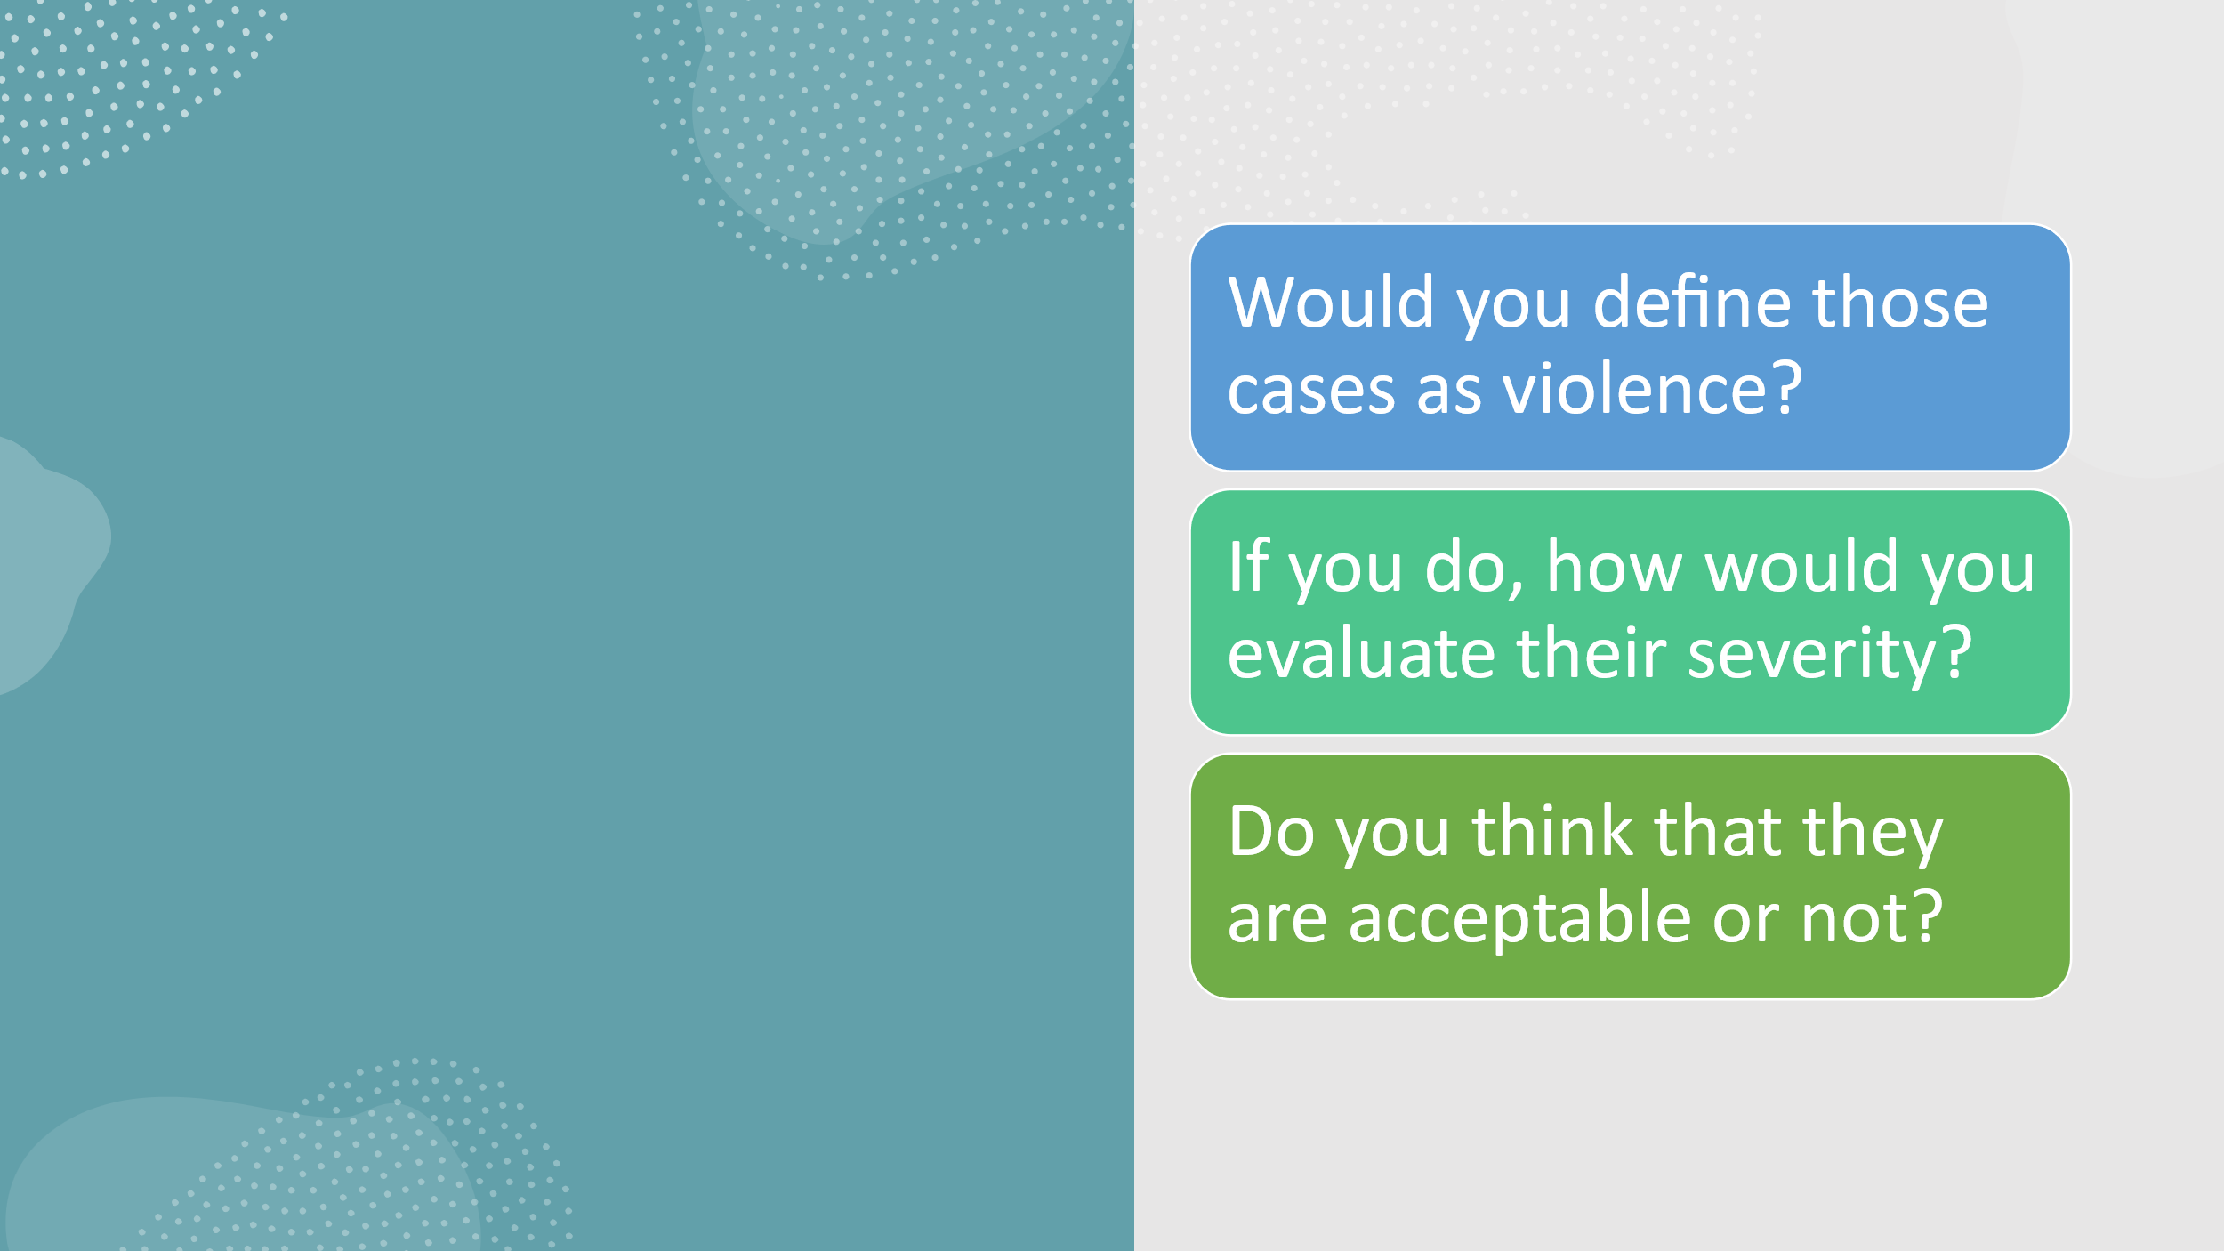
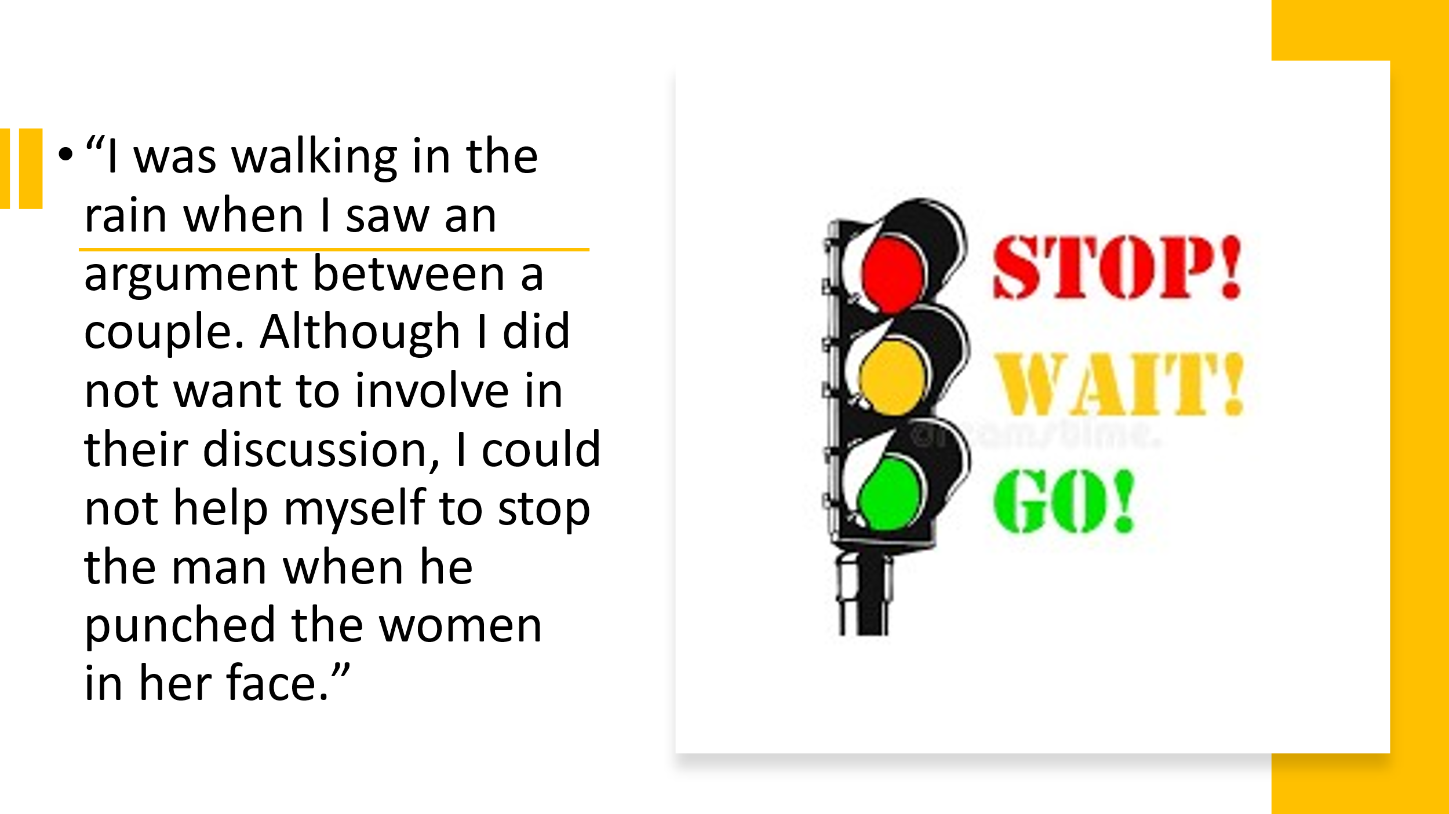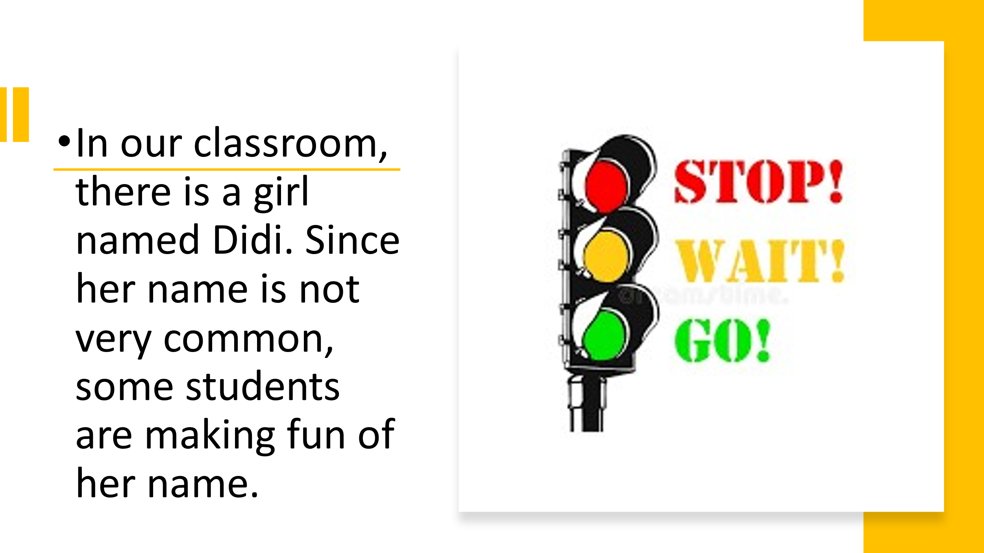
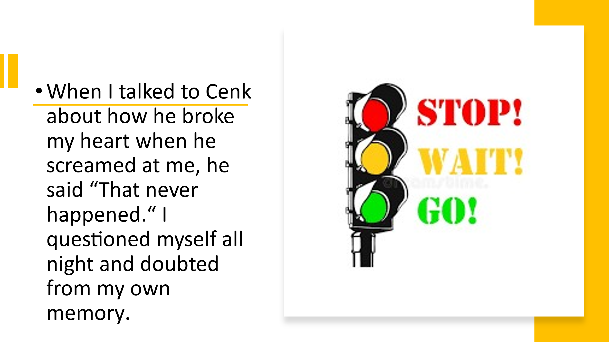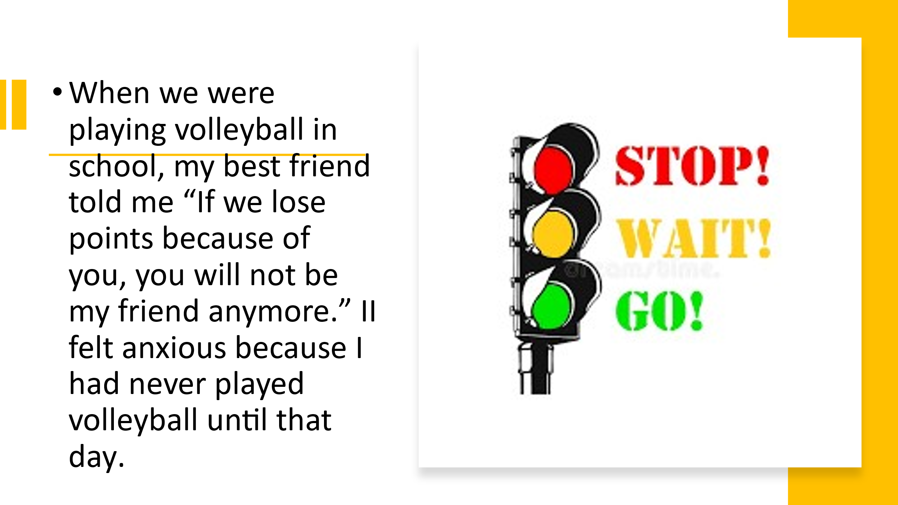
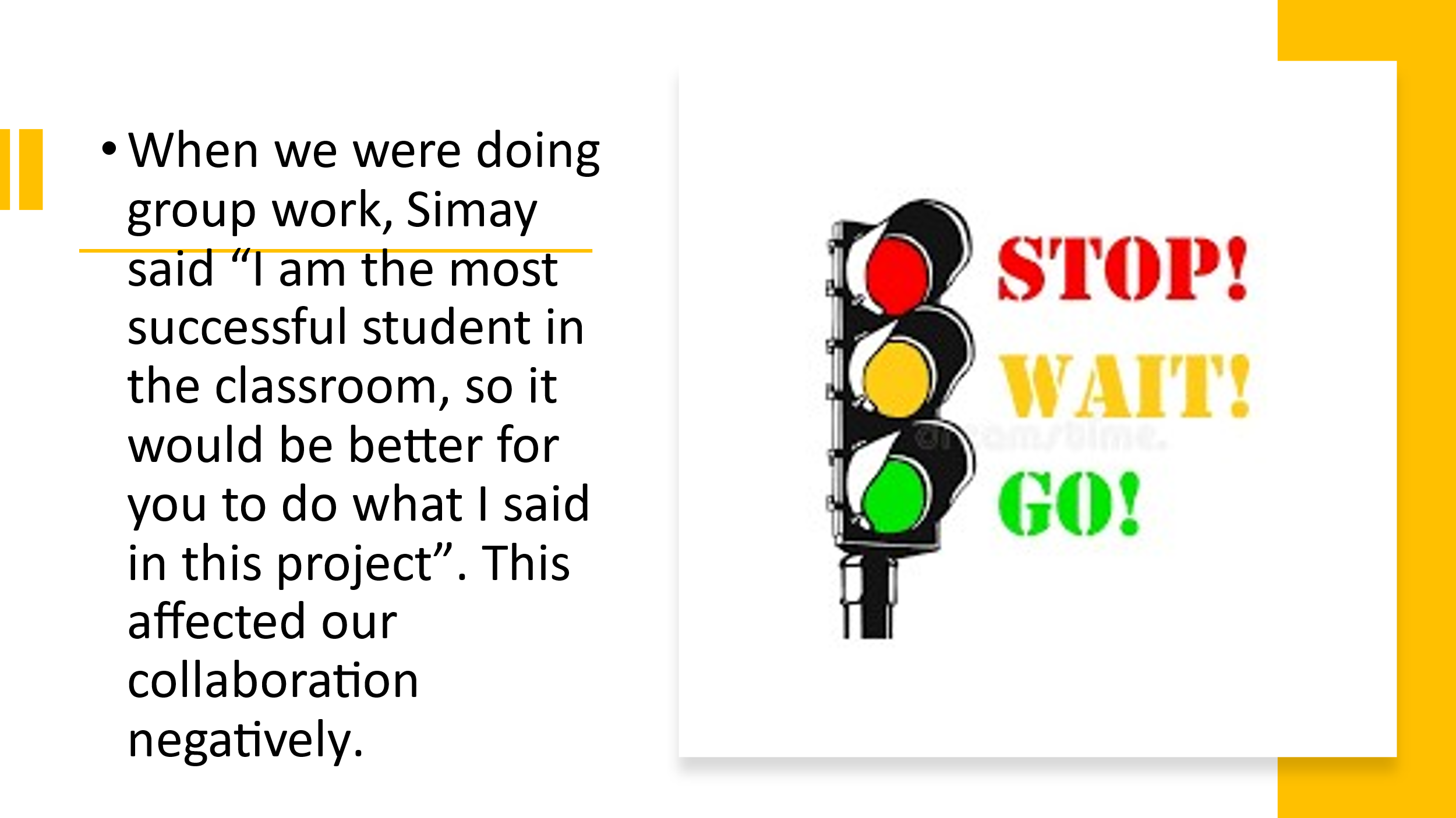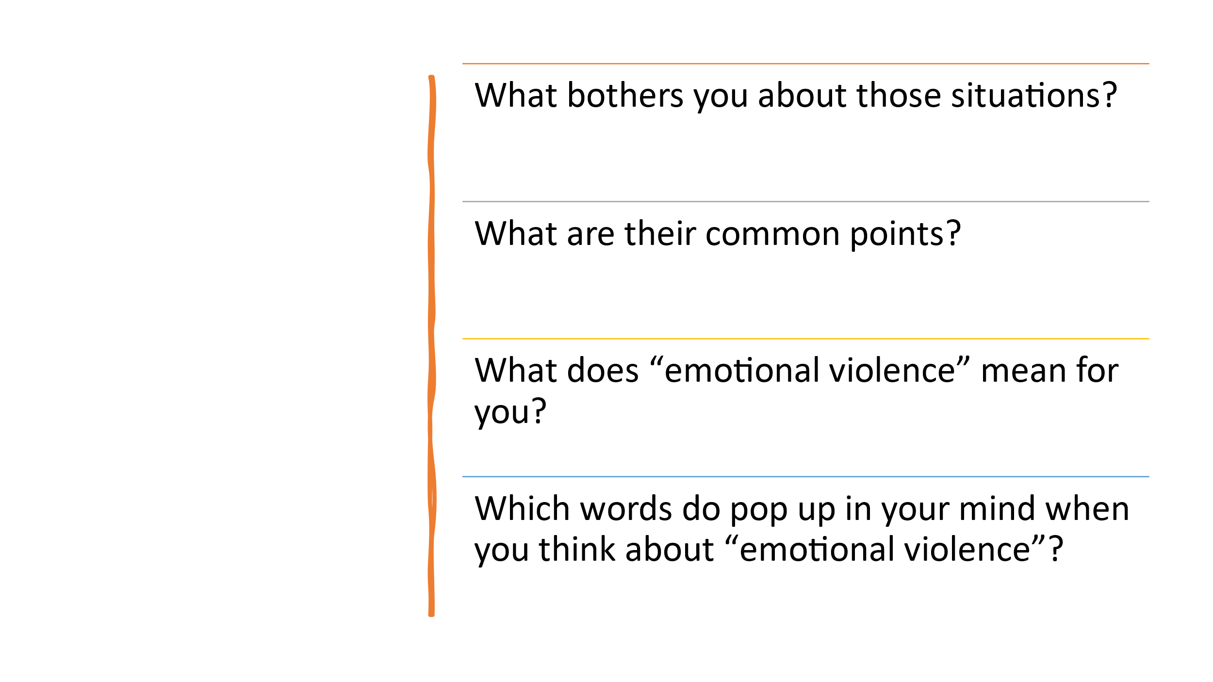
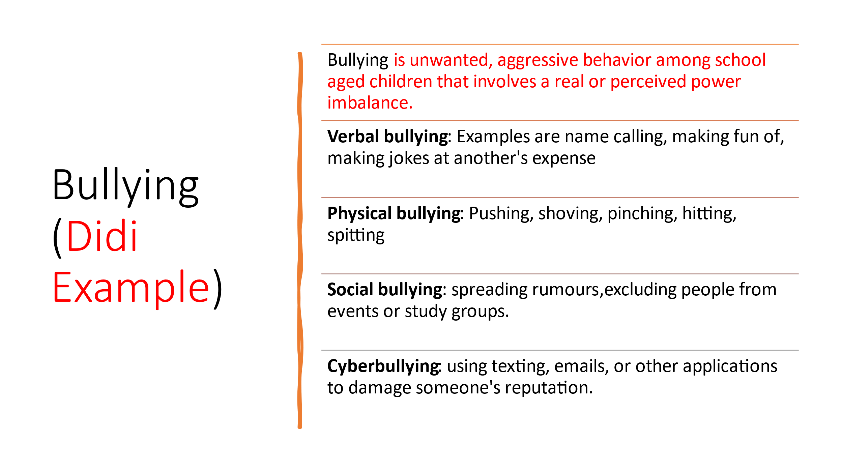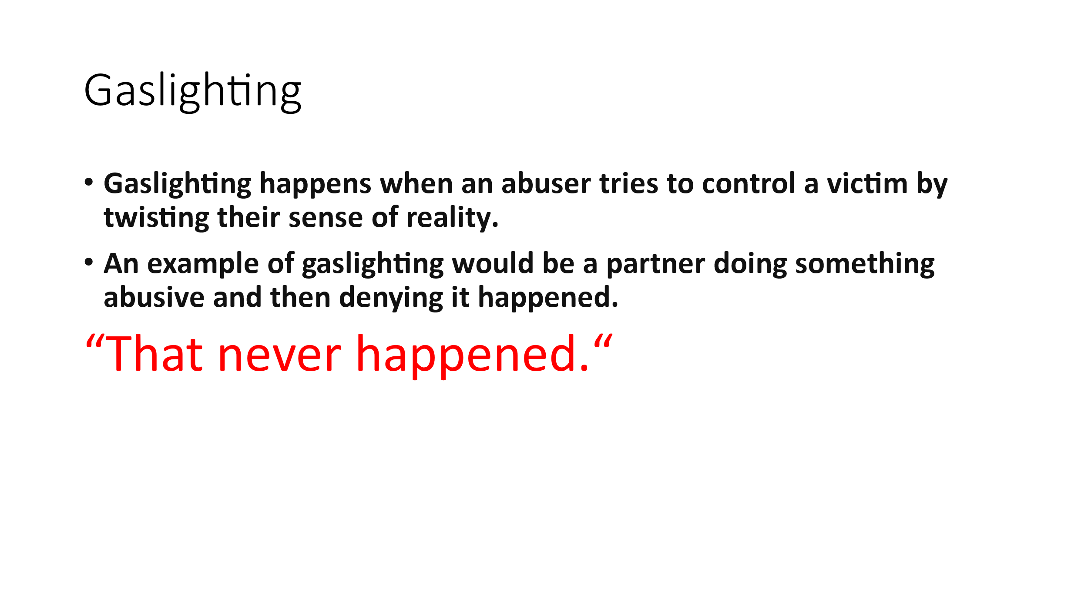
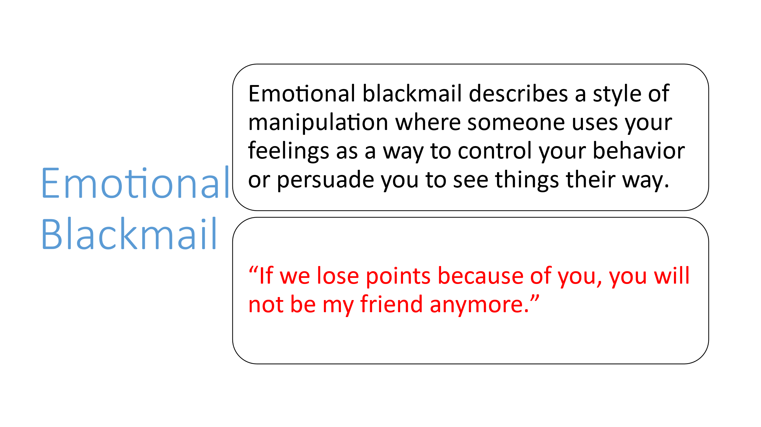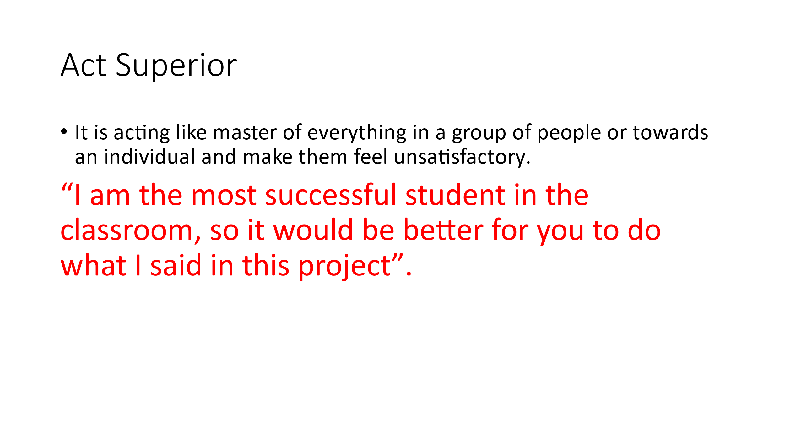
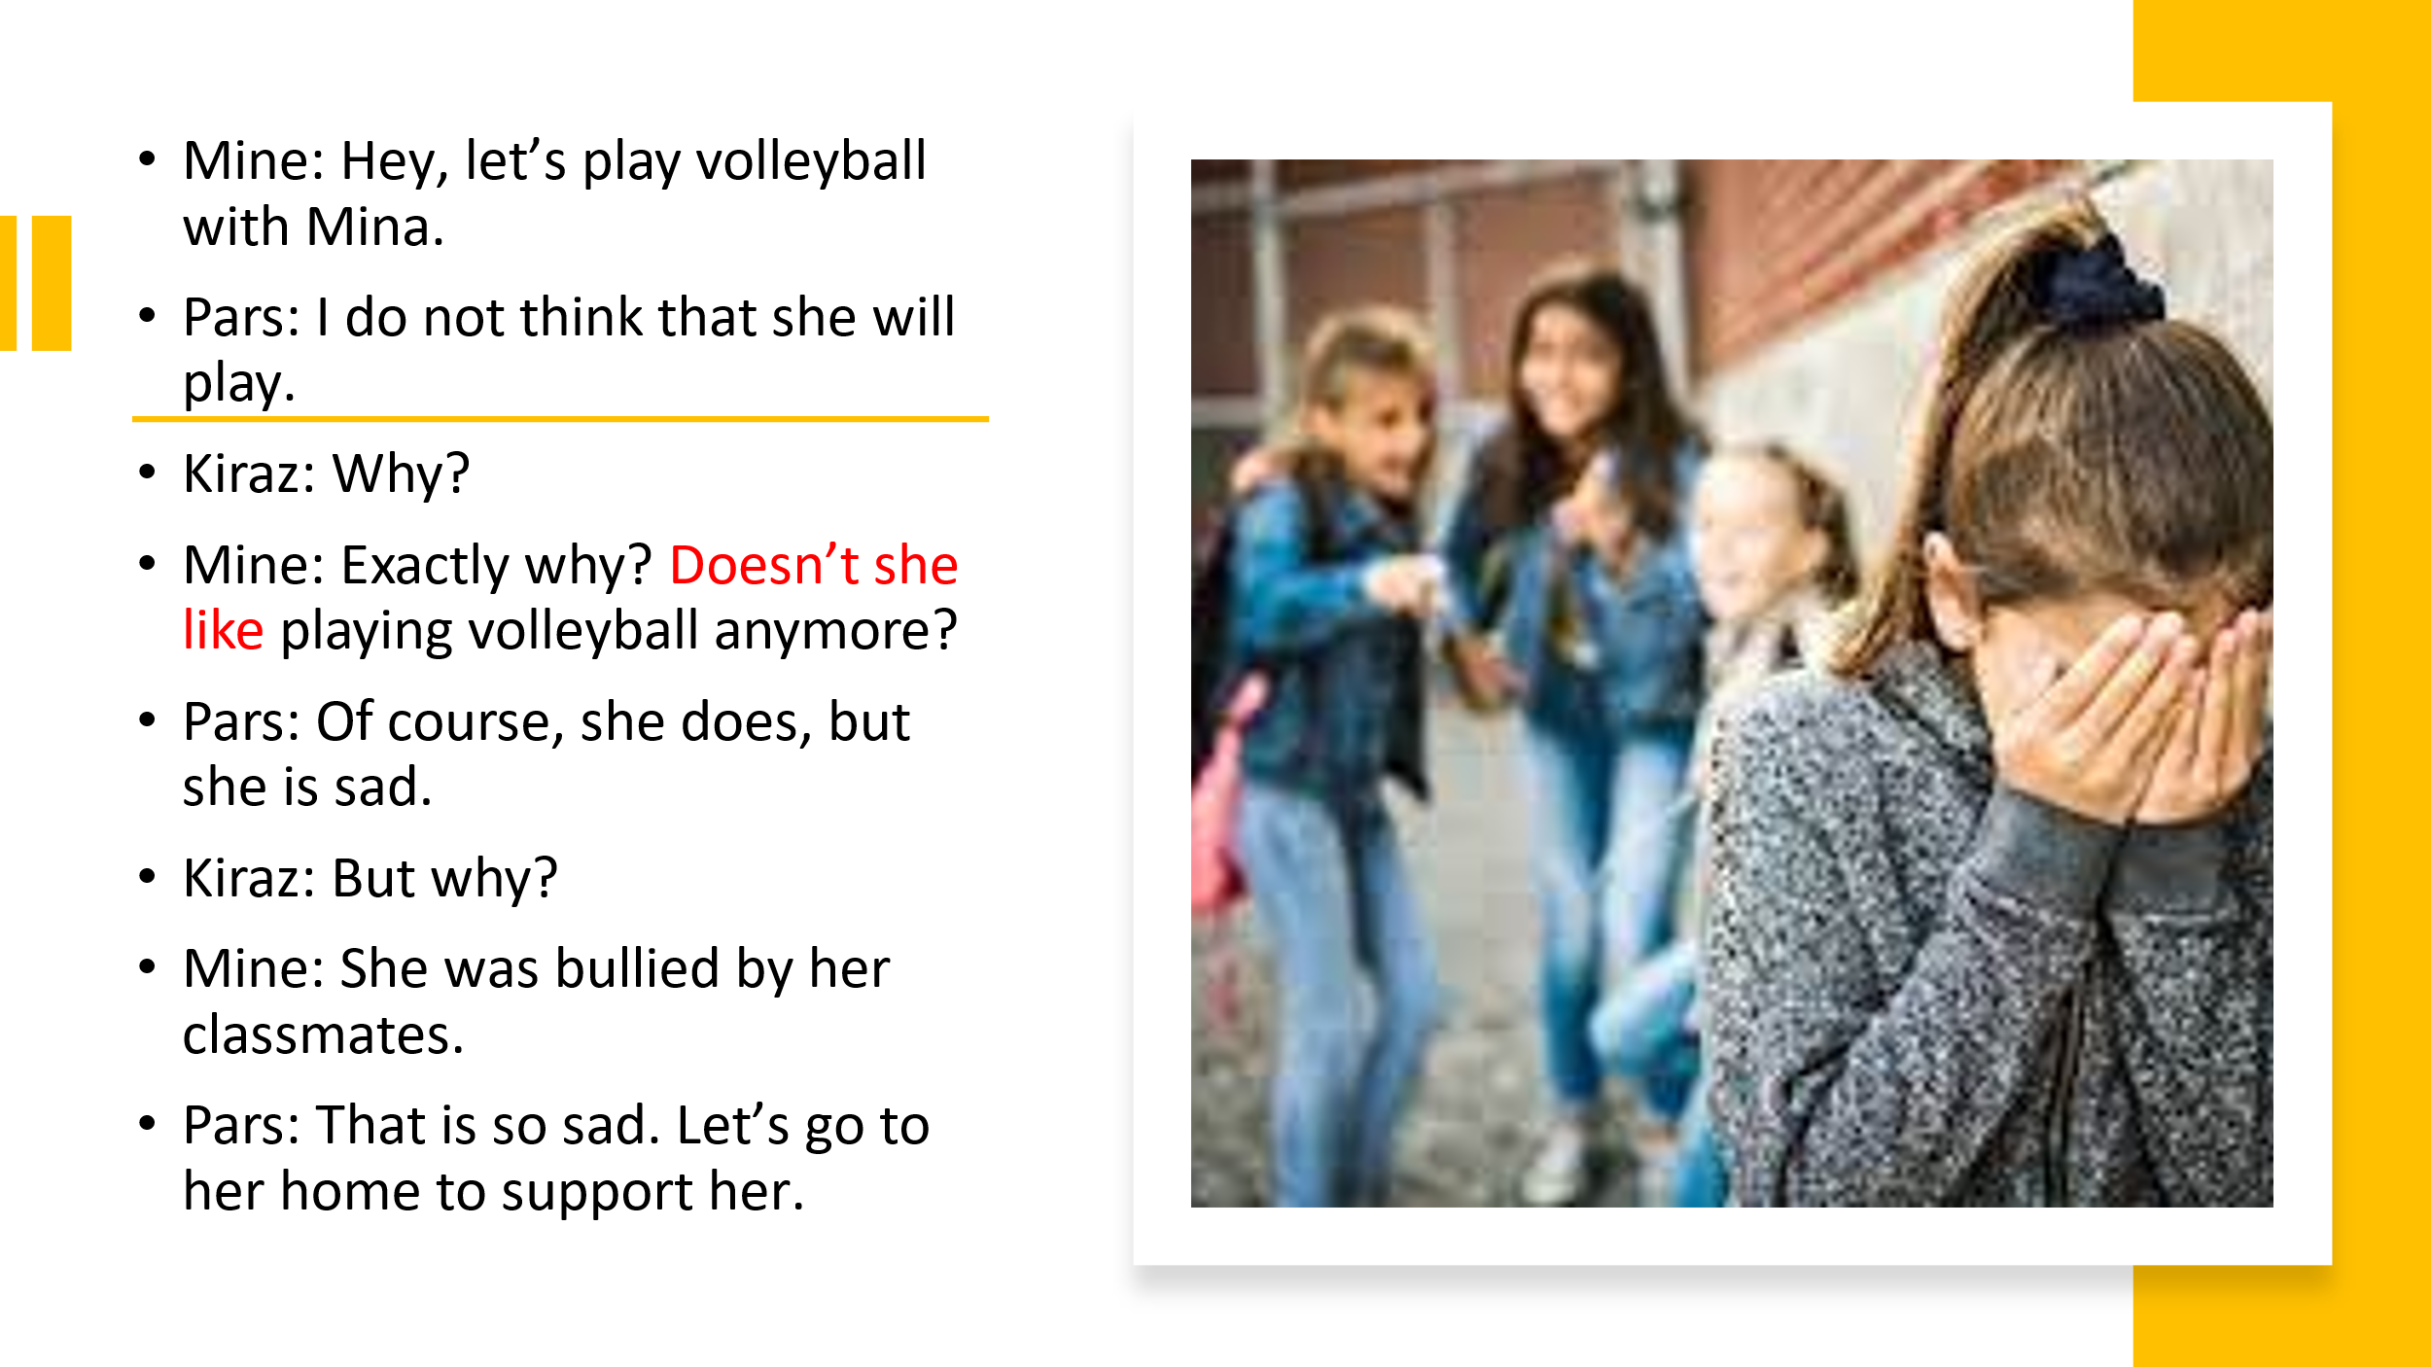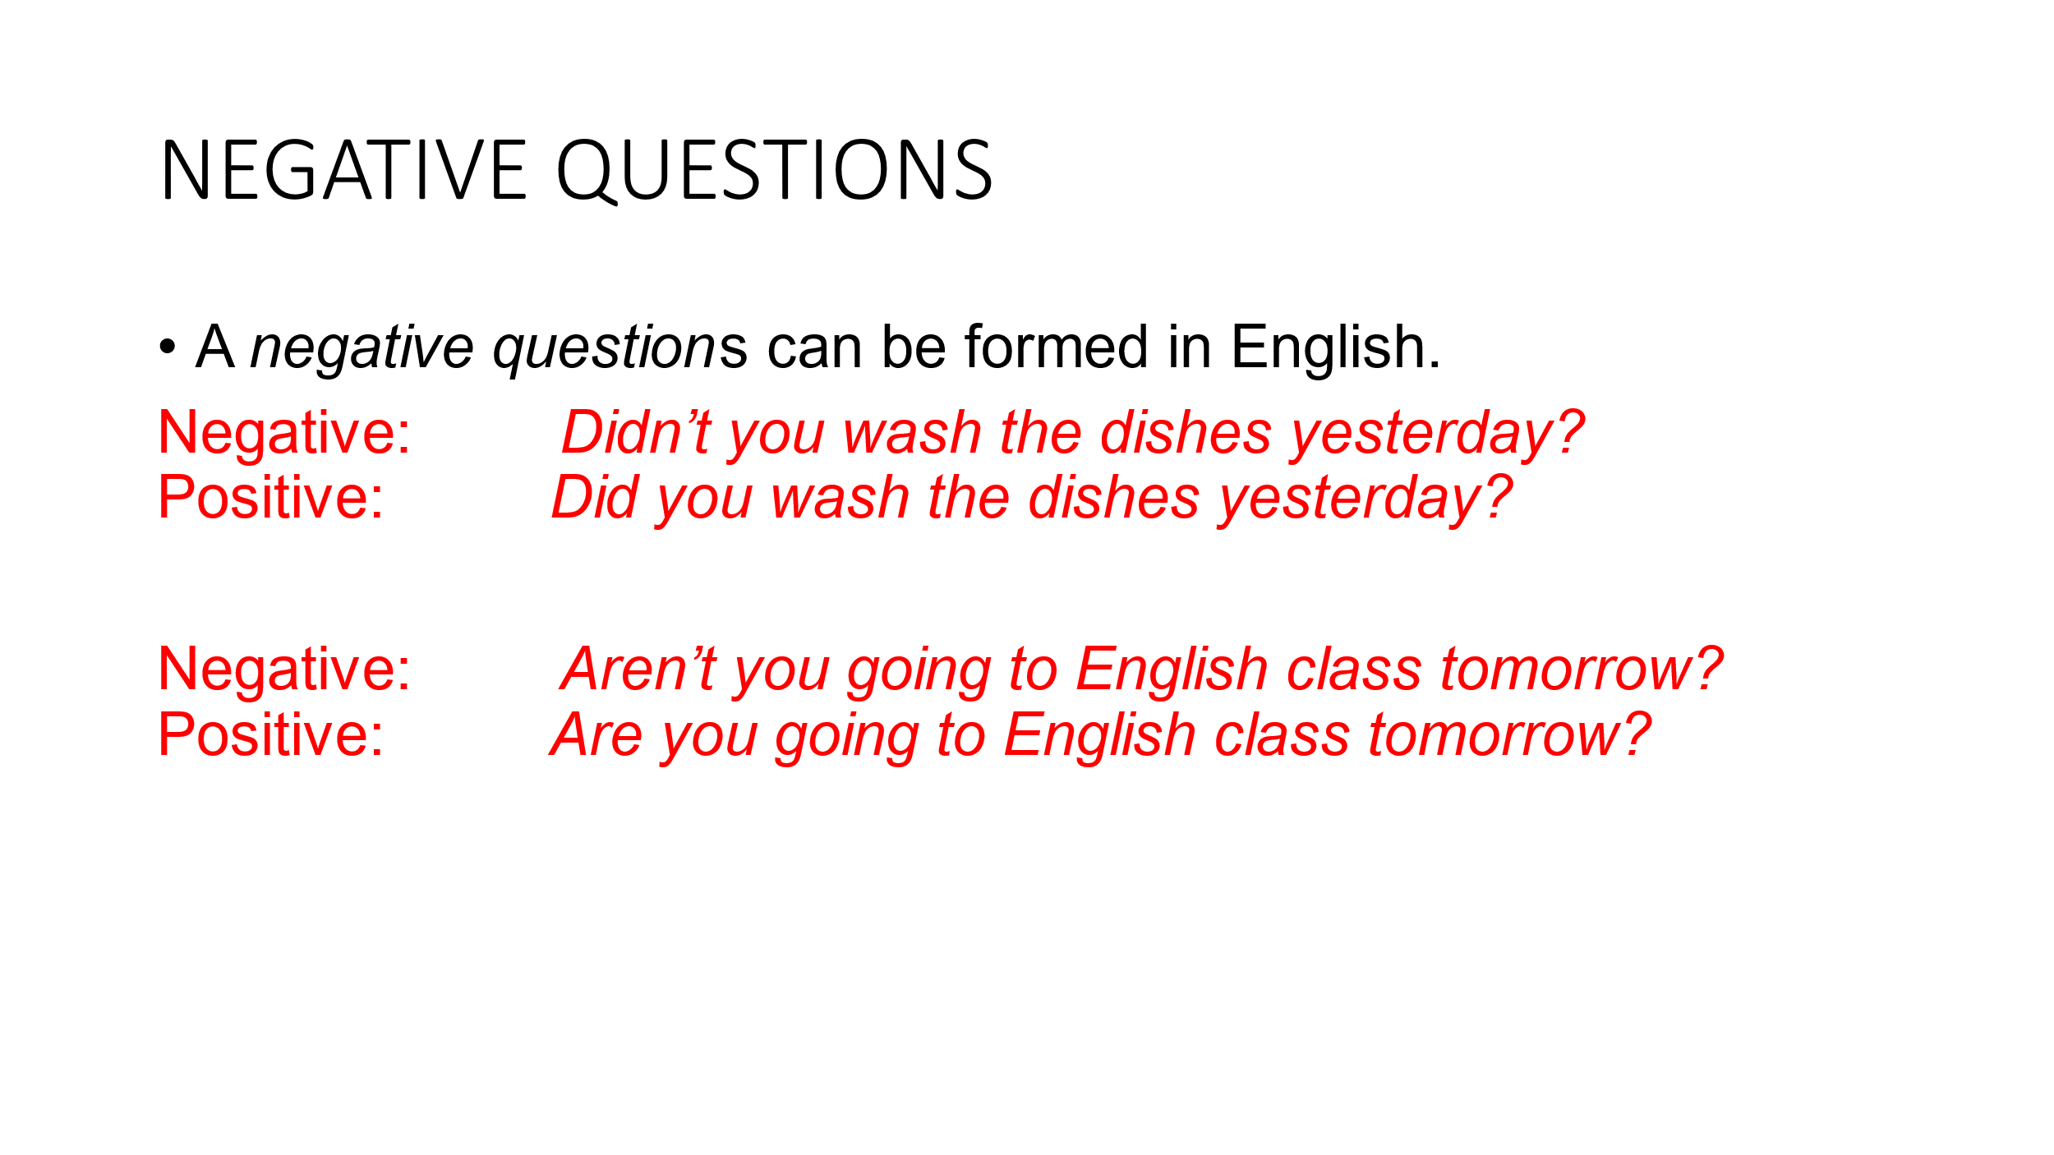
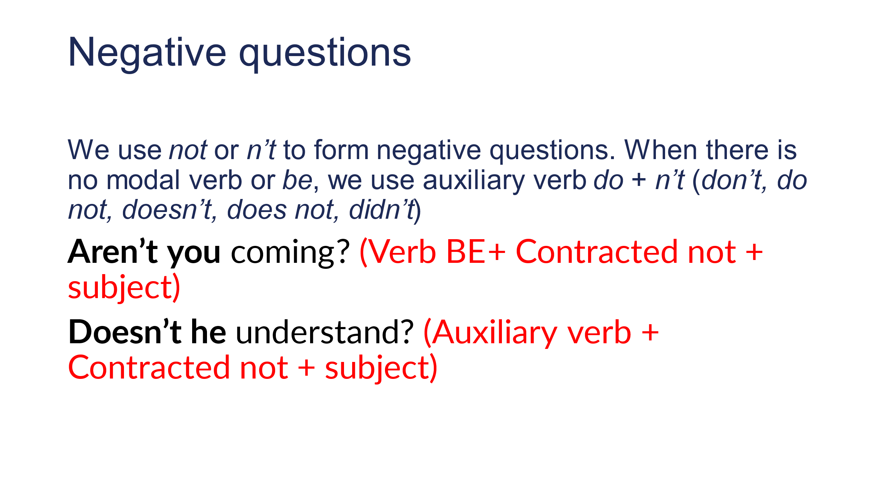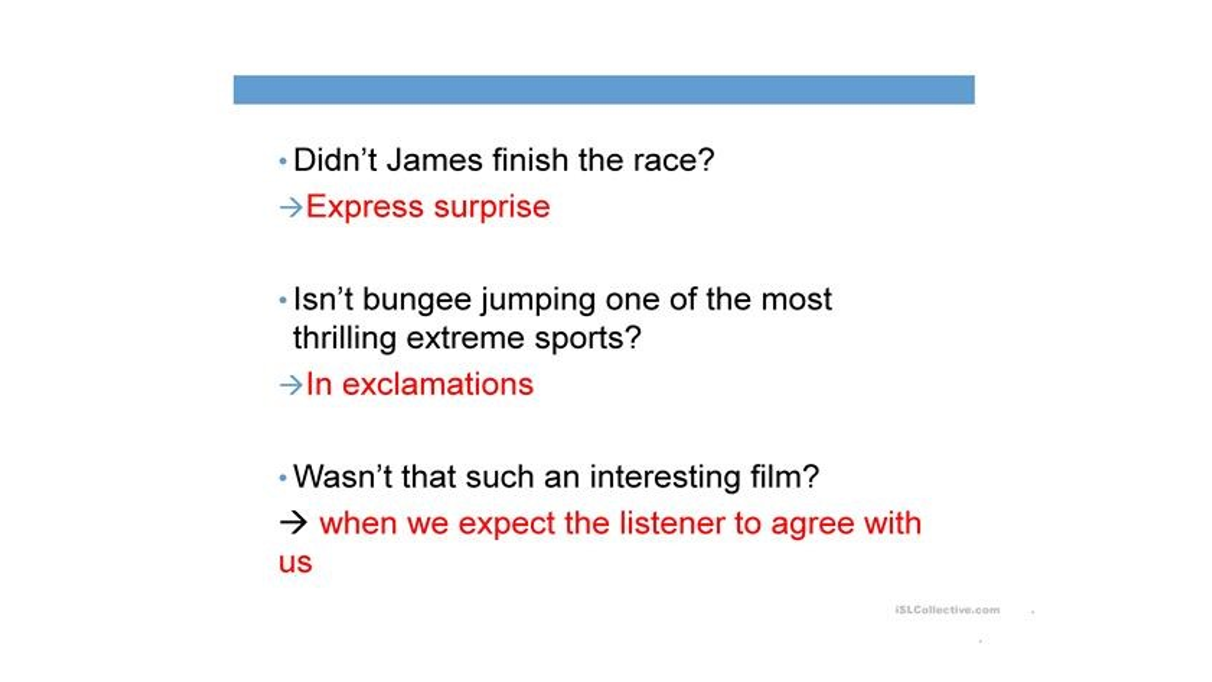
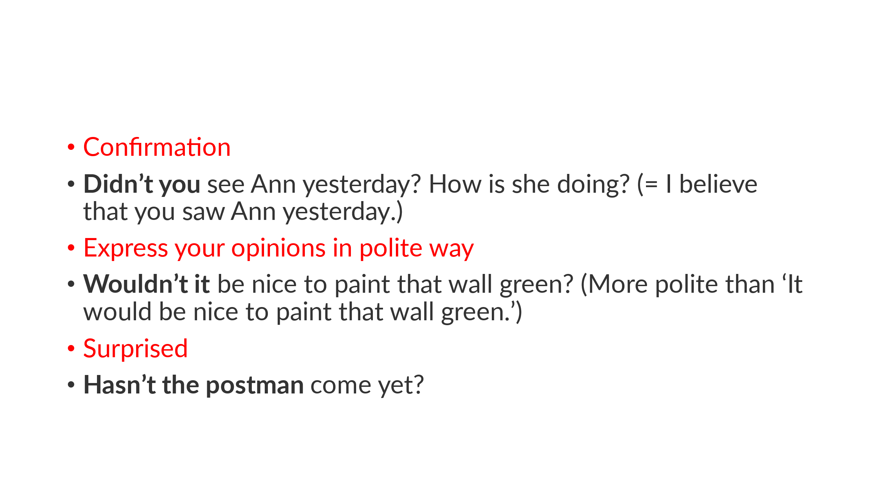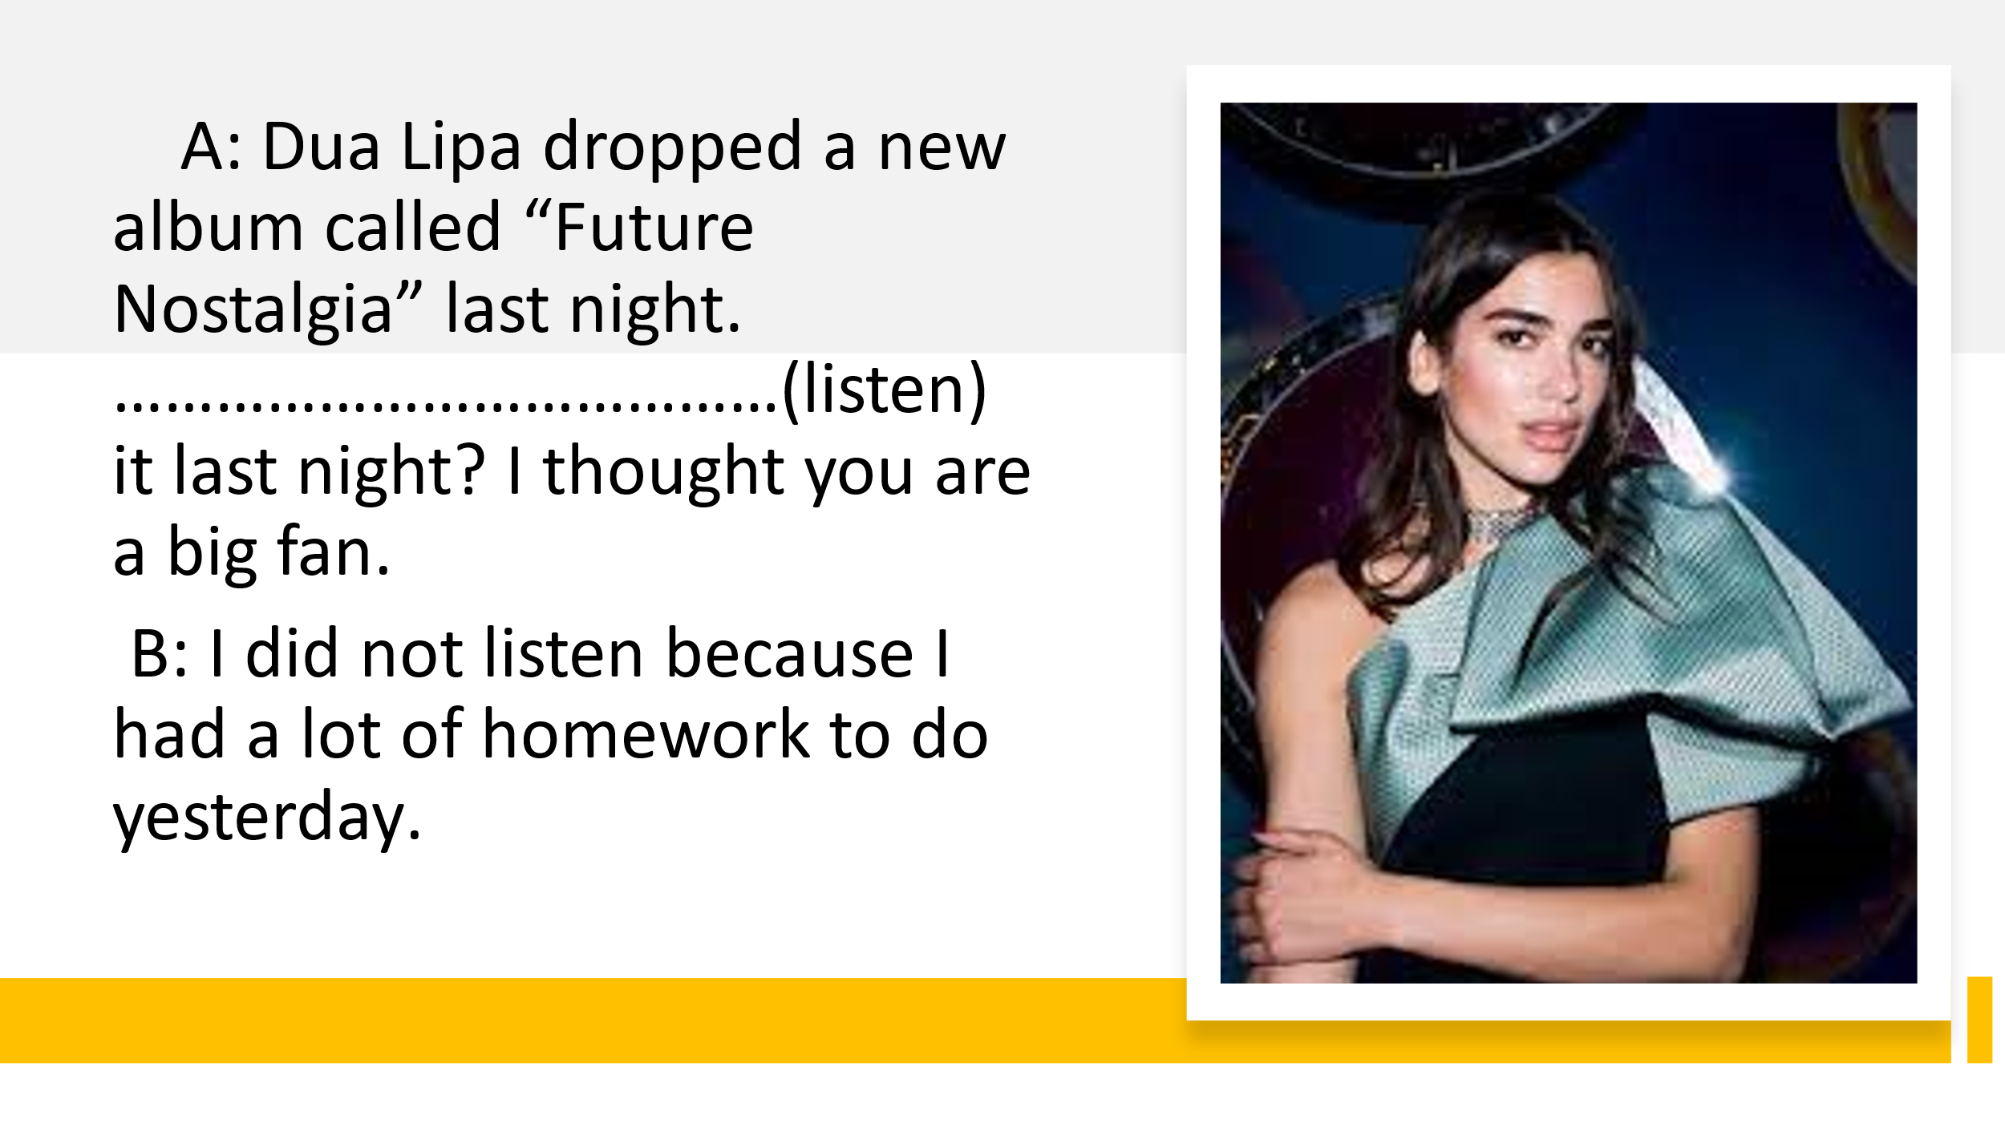
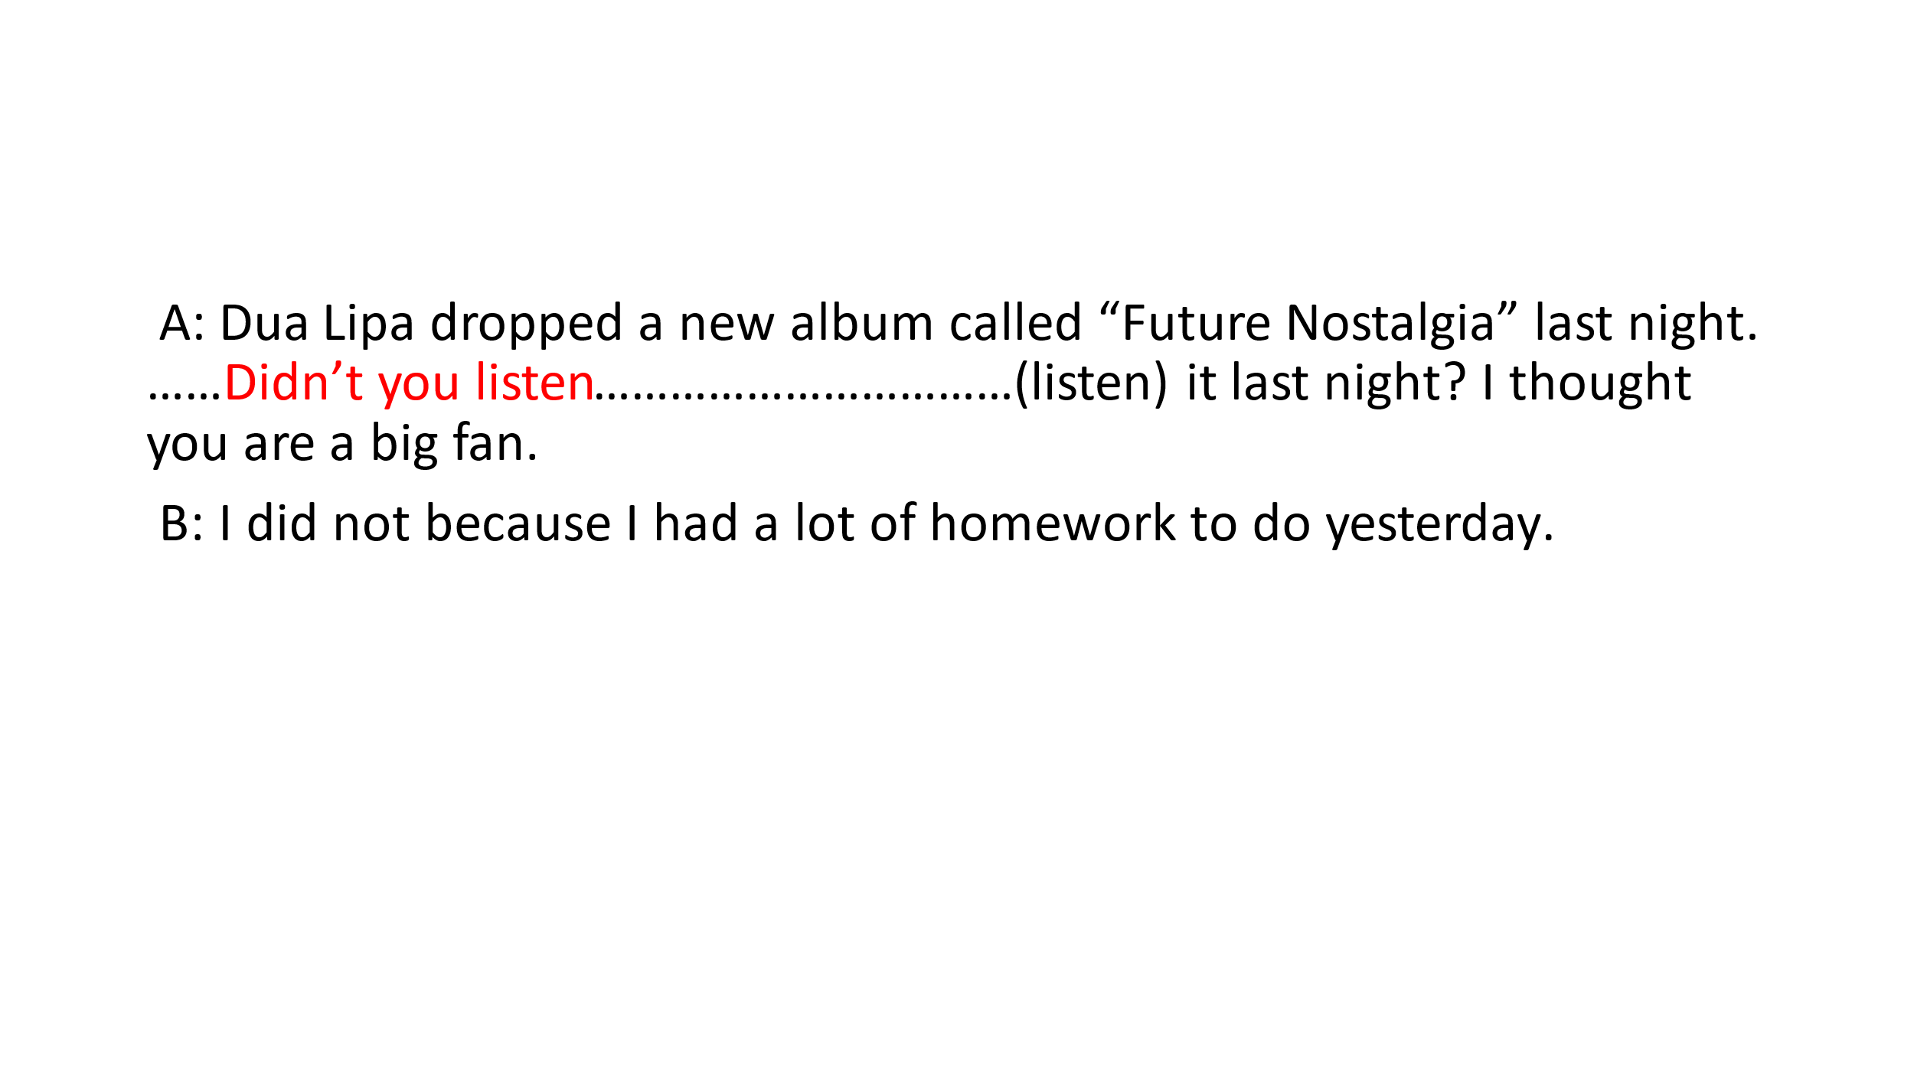
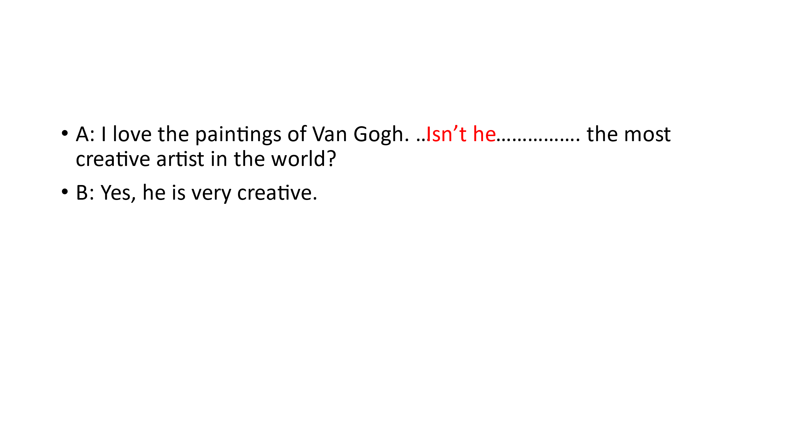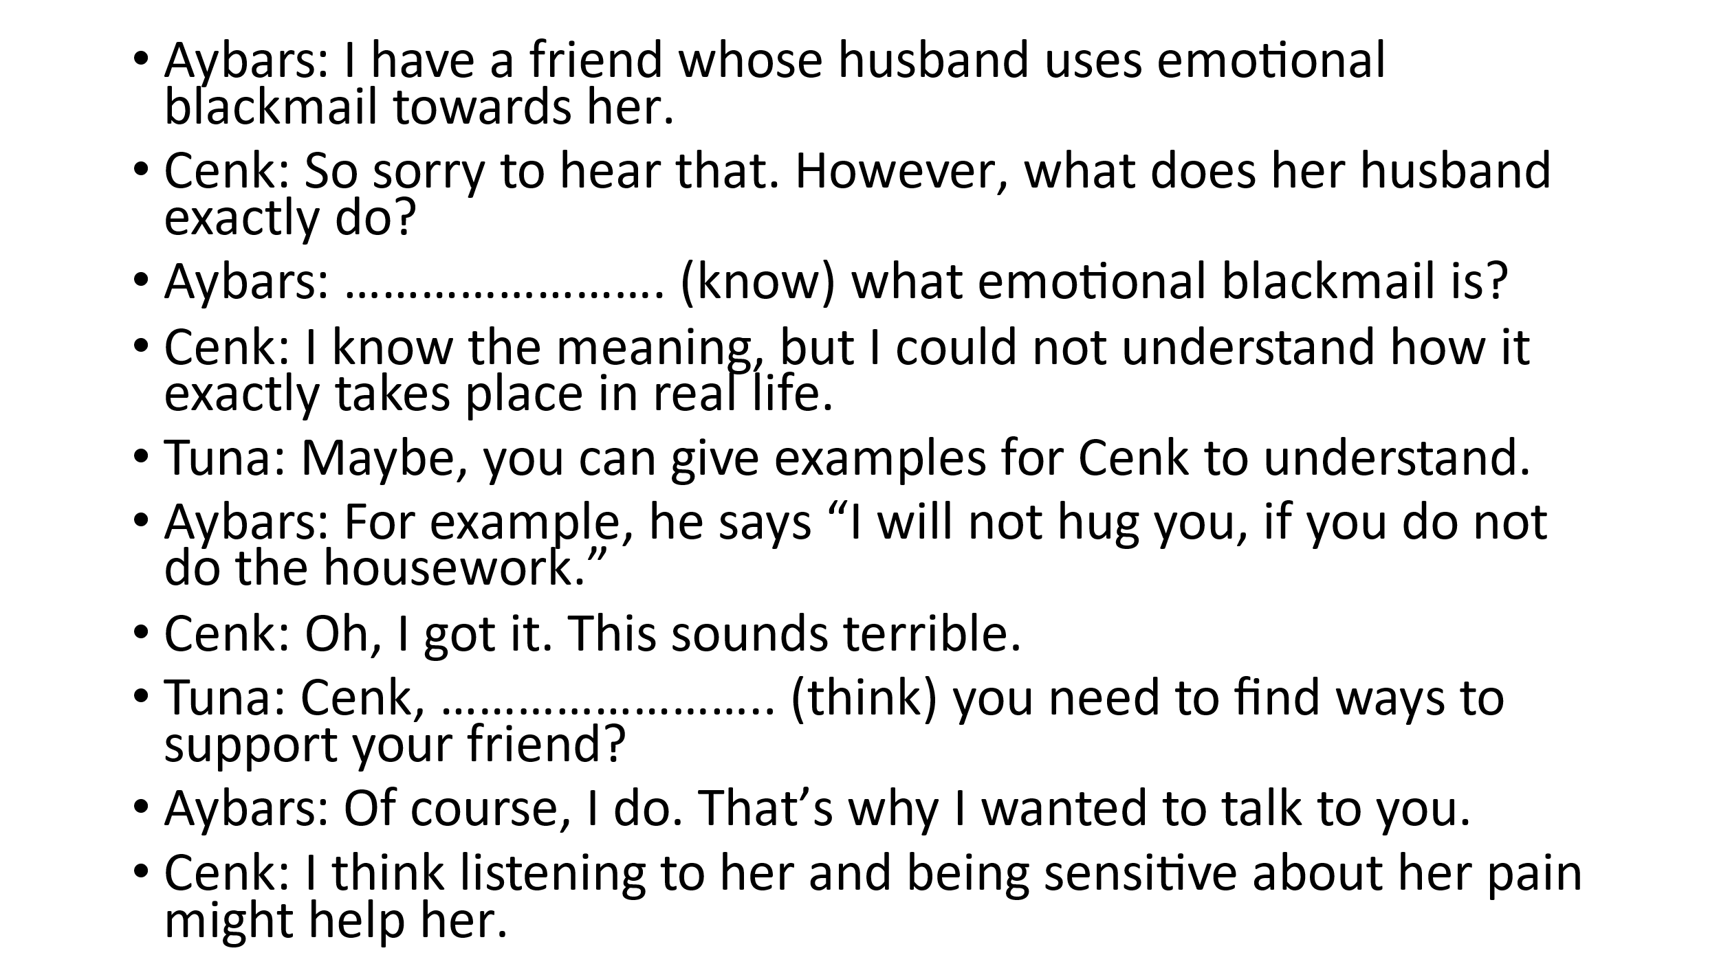
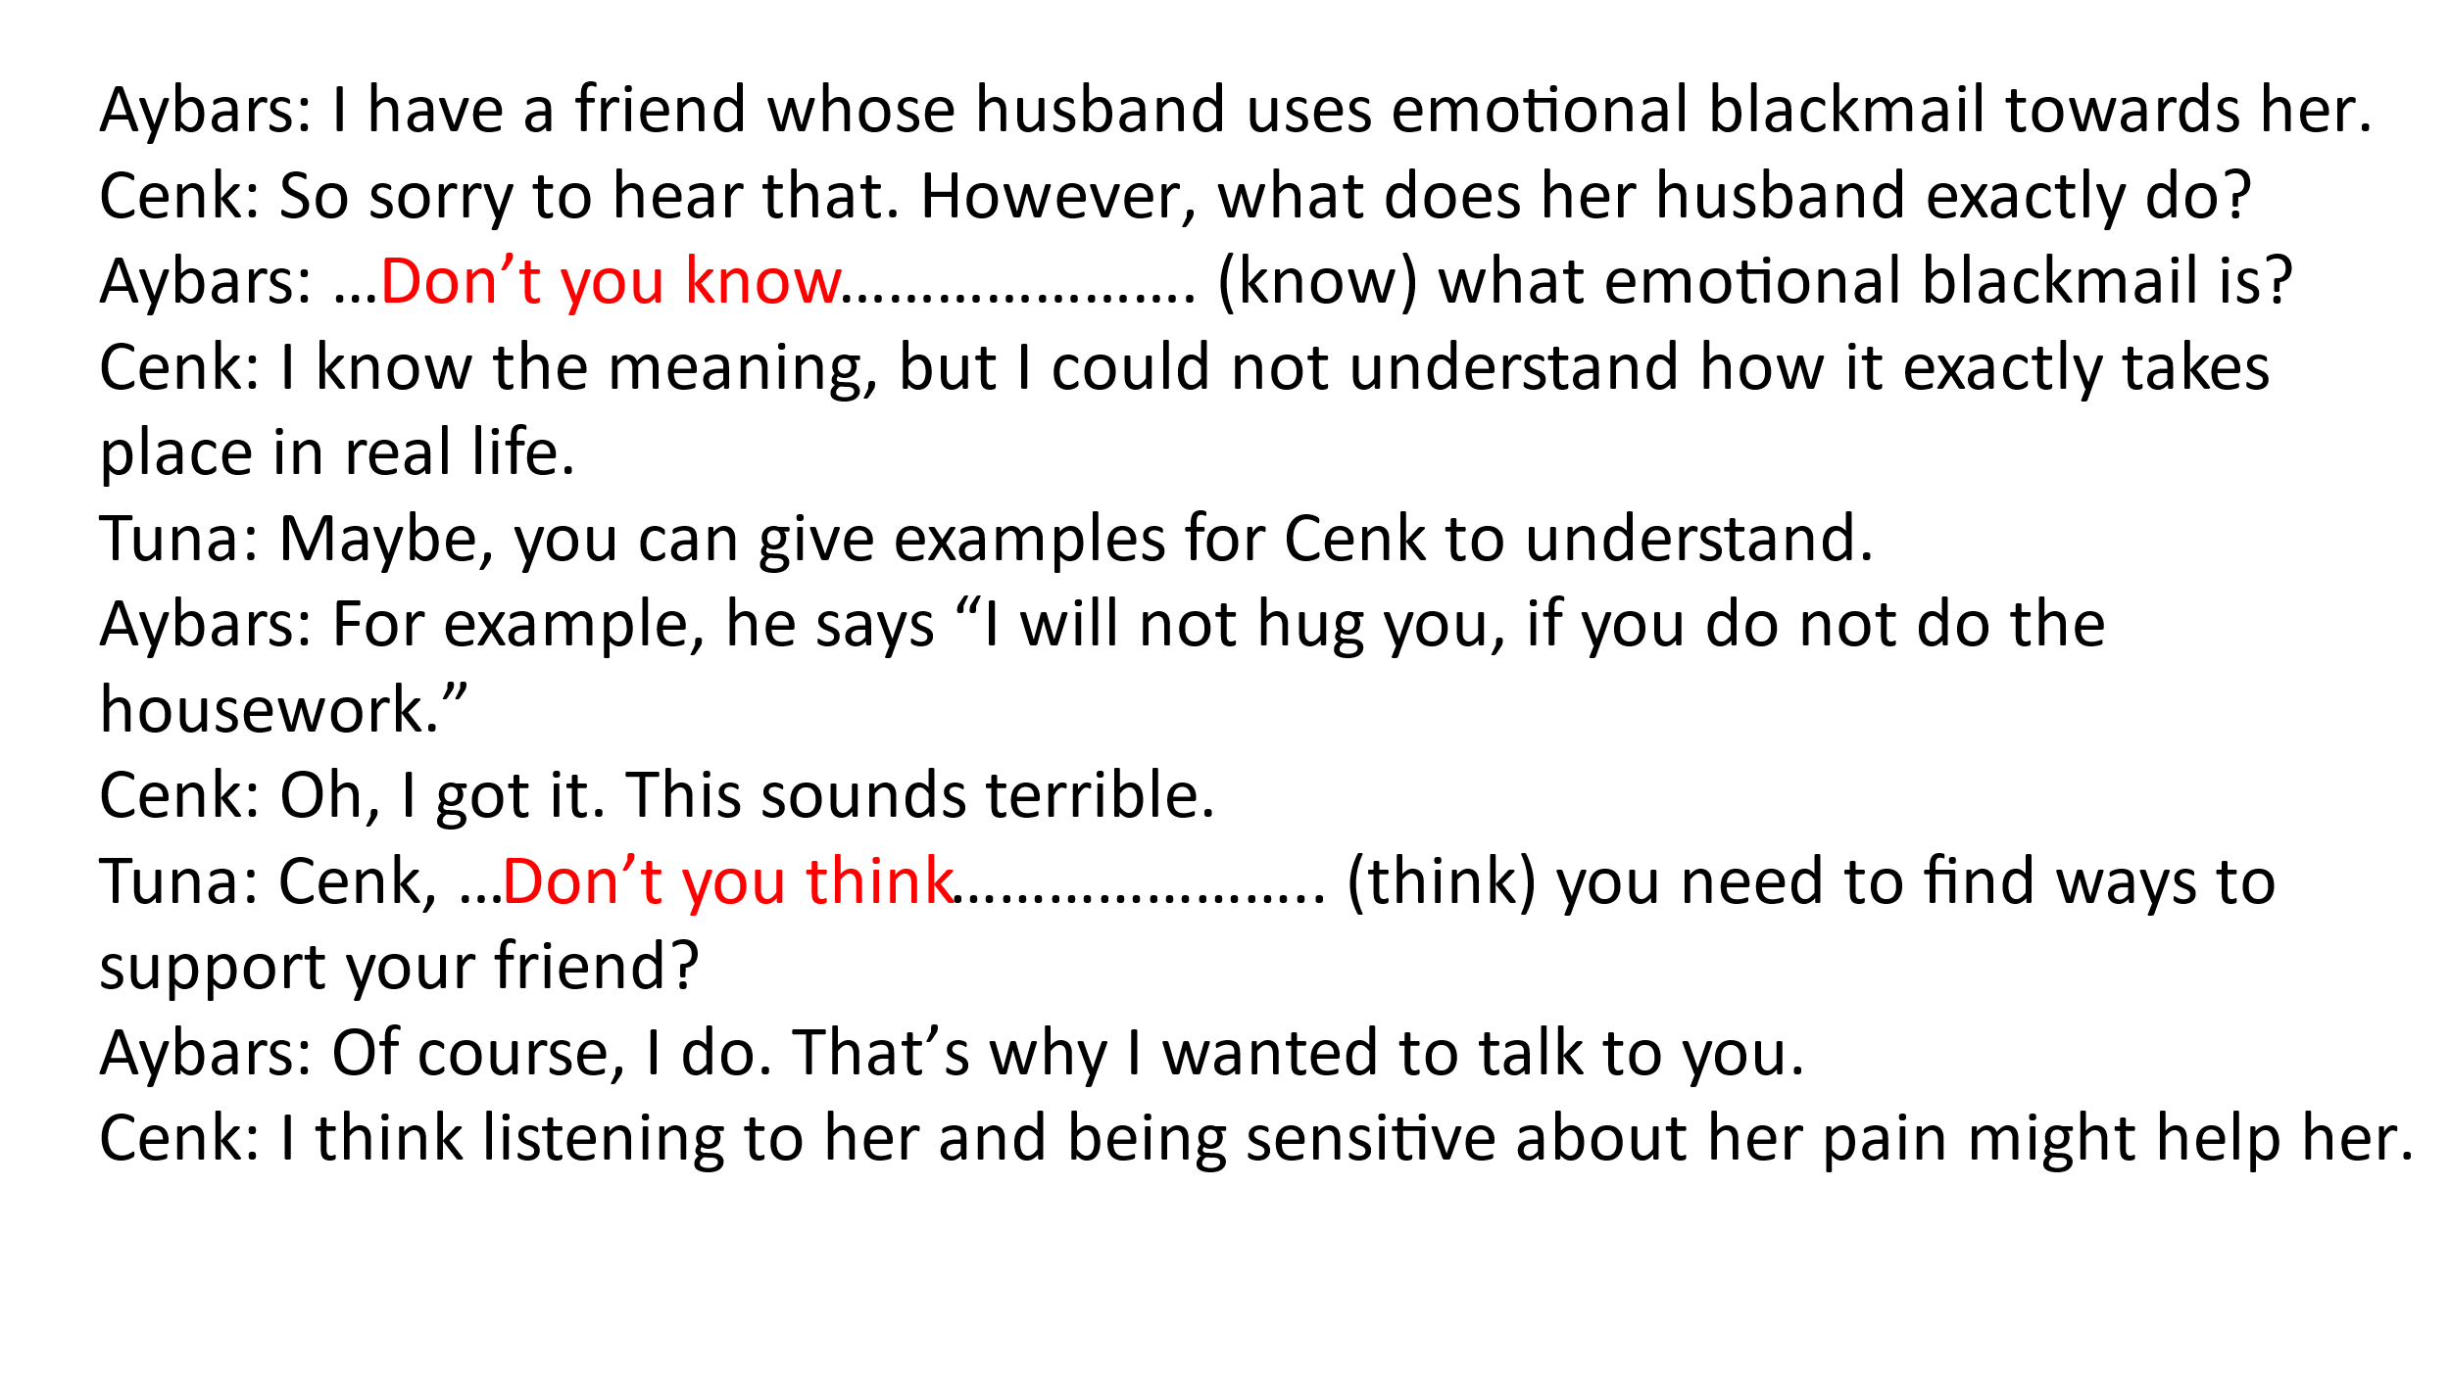

Appendix B.
