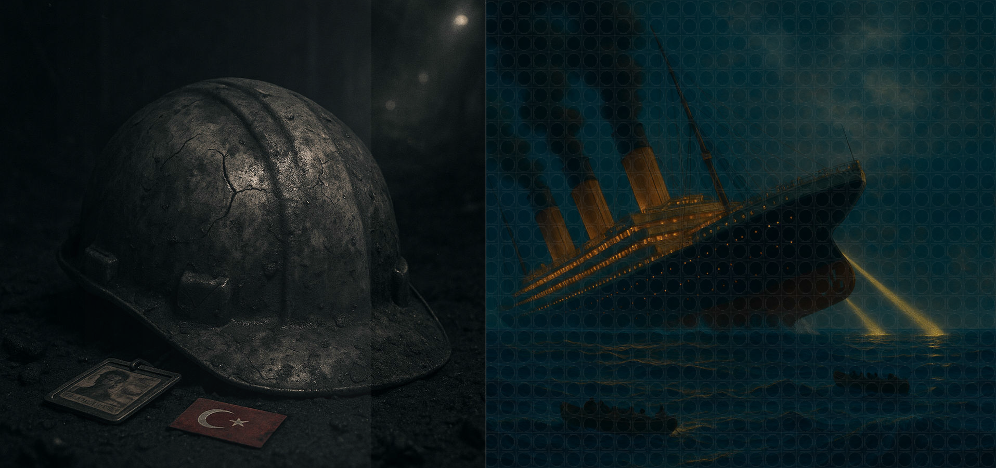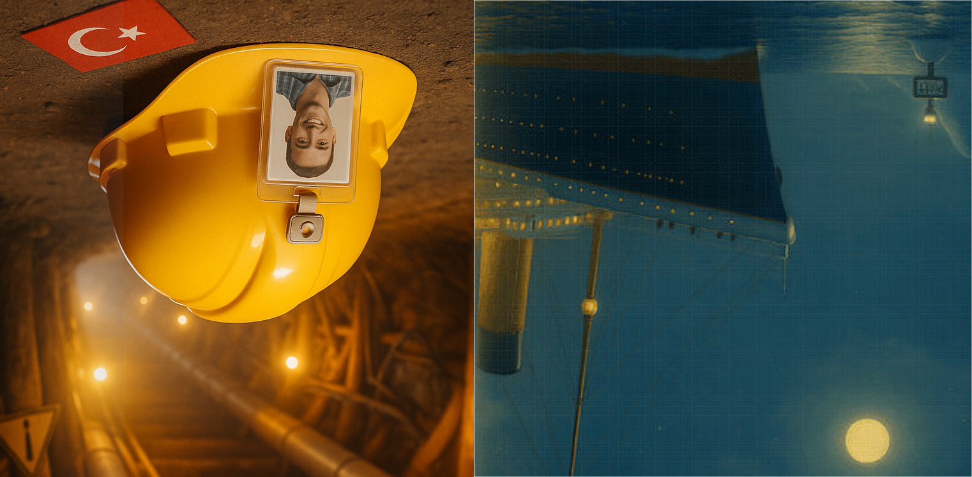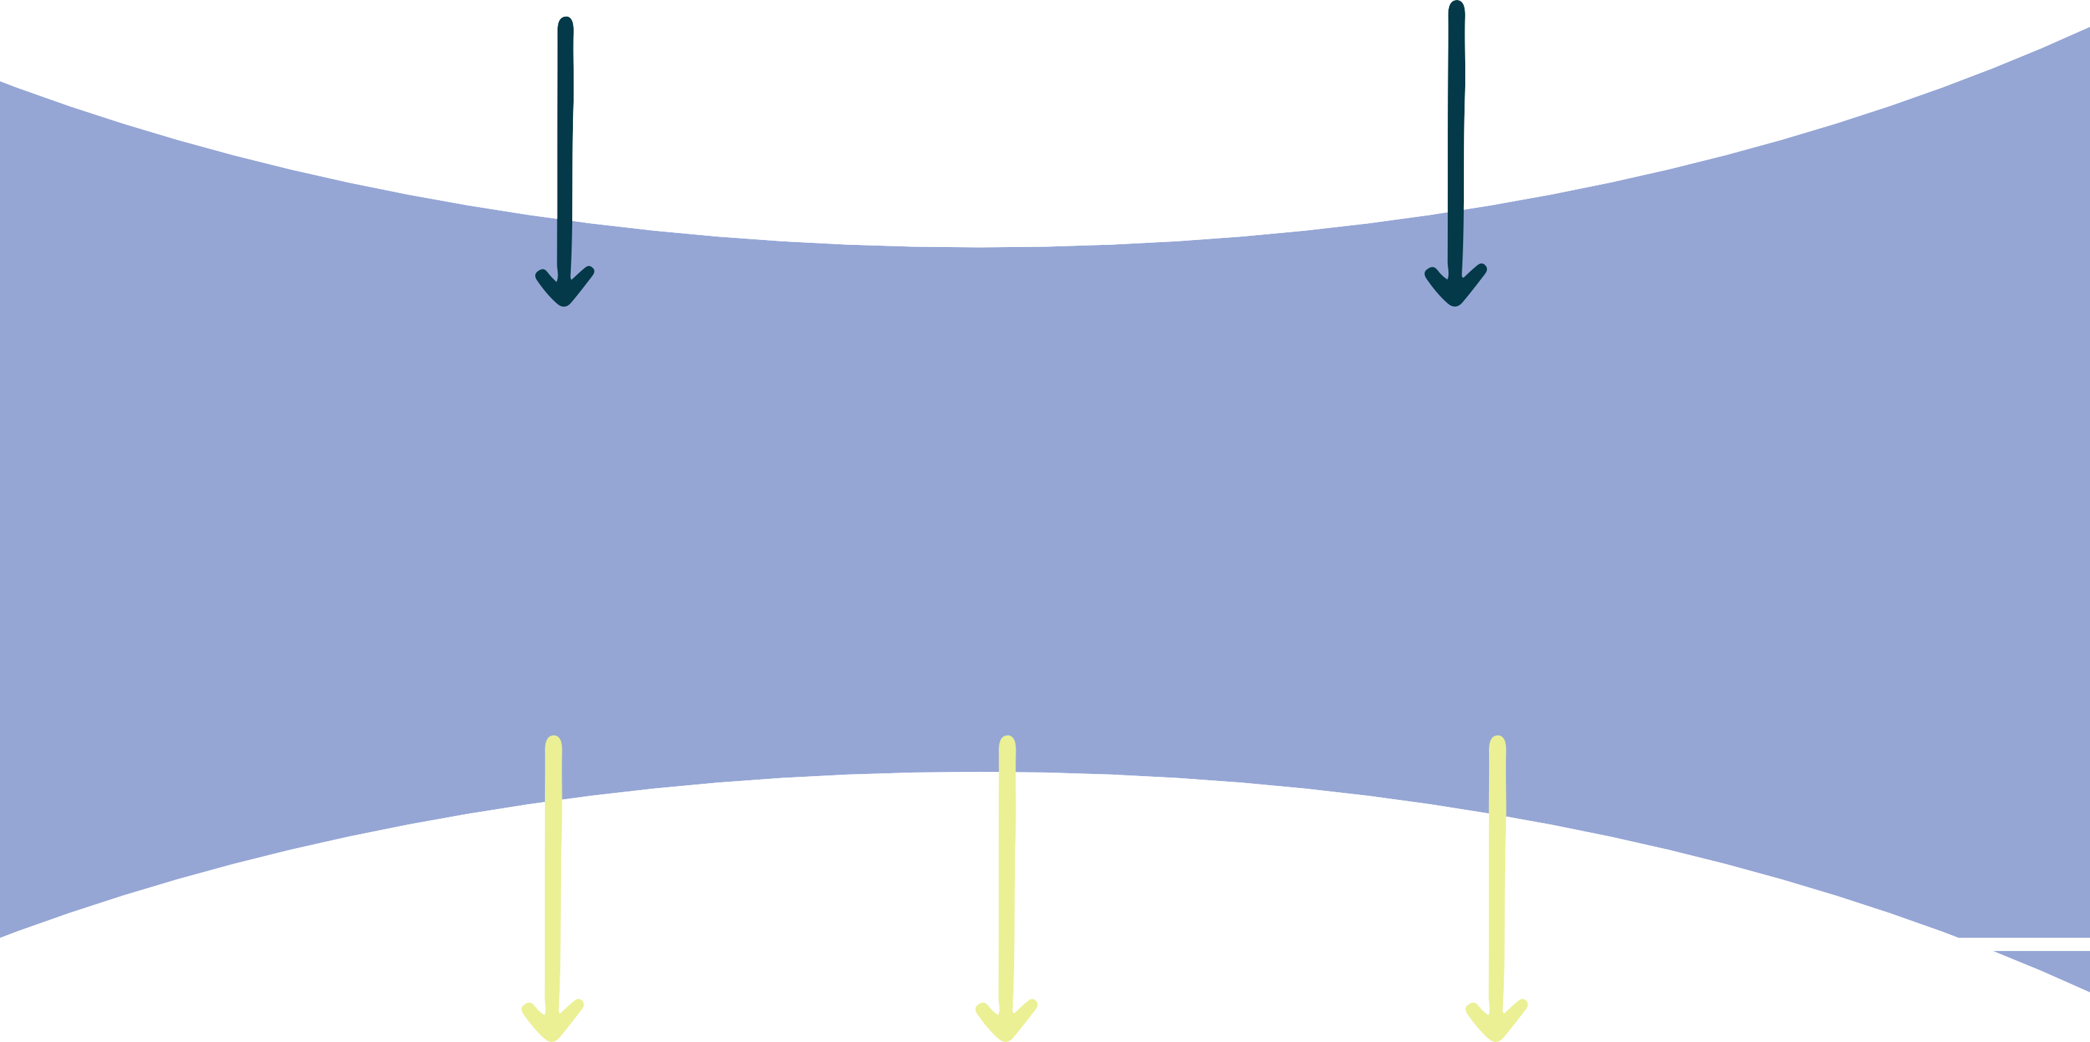

TEACHING THE PAST POSSIBILITIES WITH DISASTERS
Written by Furkan Şevket KIR
Edited by Mustafa Bozkaya

LESSON PLAN



By Furkan Şevket Kır

Suggested Grade Level: 11th Grade (17-18 years old, Intermediate level)

Material Needed: Slideshow: Kır, Furkan Şevket. Third Conditional Structure and Ship Parts Vocabulary PowerPoint Presentation
News Excerpts (Shortened and Adapted): Önal, E. (2014, May 22). Death of Mine Workers in Turkey: Destiny or Negligence. Pace International Law Review. https://pilr.blogs.pace.edu/2014/05/22/death-of-mine-workers-in-turkey-destiny- or-negligence/
Acton, James M. & Hibbs, M. (2012, March 9). Fukushima Could Have Been Prevented. The New York Times. https://www.nytimes.com/2012/03/10/opinion/ fukushima-could-have-been-prevented.html
Copping, J. (2011, December 4). The 30 seconds that sank the Titanic – fatal delay in order to change course doomed liner. The Telegraph. https:// www.telegraph.co.uk/news/uknews/8933109/The-30-seconds-that-sank-the- Titanic-fatal-delay-in-order-to-change-course-doomed-liner.html
Movie Trailer: Titanic - Official Trailer (1997) [Video]. Dailymotion. https:// www.dailymotion.com/video/x3uxiw4
Reading Text (Extracted and Adapted): Rosenberg, J. 20 Surprising Facts About the Titanic. ThoughtCo. Updated on May 30, 2019. https://www.thoughtco.com/ little-known-facts-about-the-titanic-1779209
Pictures of old famous people, disasters and icons of social media platforms

Length of Time:
50 minutes

Goals
Students will be introduced to the structure and meaning of the third conditional. Students will practice using the third conditional in controlled and freer activities.
Students will engage with authentic materials (e.g. news excerpts, movie trailer) to understand the use of the third conditional.

Objectives
By the end of the lesson, students will be able to:
recognize the meaning and third conditional structure of sentences in the news excerpts.
complete 5 sentences in the third conditional based on the information in the reading text.
write at least 3 sentences in the third conditional using the pictures given by the teacher.

Process

- 1. Set it up: Greet students and ask how they are. Briefly share something about your life, then ask students if they have anything to share or any interesting news. Listen if they do; if not, mention having something to share. Before sharing, stick disaster-related pictures (Appendix A) on the board. Ask students to guess where the pictures were taken. After listening to guesses, state that the pictures were taken during disasters and announce that the lesson will focus on this topic.

- 2. Let it run: Distribute handout with news excerpts (Appendix B) from different websites. Tell students to try to understand the news, identify common themes, and allow a few minutes for this. Ask if the news items have something in common and try to guide them to they are about preventable disasters. Instruct students to re-read the news excerpts closely and have them underline sentences that suggest it was possible to prevent these disasters. After individual work, ask students to check their underlined sentences with a partner. Ask a few students to share the sentences they underlined. Reflect these sentences on the board using a projector. Focus on the meaning of these sentences by asking concept-check questions (e.g., "Did they take necessary measures before the Soma disaster?"). Then, focus attention on the sentence structure and the differences in meaning when using "would," "could," or "might" in the main clause. Transition to the Titanic example by mentioning theories about how more people could have survived. Play the trailer of the movie "Titanic." Ask students to recall events and think about what could have been done differently for more survivors. After the trailer, briefly discuss the mistakes made during the passenger evacuation and what could have been done to save more people. Announce a focus on 5 facts that could have saved more passengers. Before distributing the next text, show and explain potentially unfamiliar vocabulary about ships (drill, distress flares, funnel) using a PowerPoint presentation (Appendix C). Distribute the handout (Appendix D). Instruct students to complete the sentences in each paragraph based on the given information, reminding them to use correct verb forms for the third conditional.

3. Round it off: Announce a fun activity after the serious work on disasters. Provide pictures of famous
people (Appendix E) from the past. Ask students to imagine what would have happened if these people had had today's technology (e.g., social media, iPhone). Provide icons or pictures of these websites and devices (Appendix F) to aid creativity. In pairs, have students match one person with one icon/device. Instruct pairs to write at least 3 sentences using the third conditional based on their match (e.g., "If Mona Lisa had had an Instagram account, she would have posted a lot of selfies."). At the end, facilitate a class decision on the most creative idea.
(Contingency: If time allows, ask students to write a few sentences about measures that could have been taken to prevent the Soma mining tragedy.)

Assessment and Evaluation

Assess students’ comprehension of the third conditional's meaning and structure from their underlined sentences in the news excerpts and their answers to concept-check questions.

Appendices

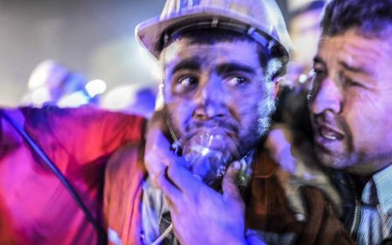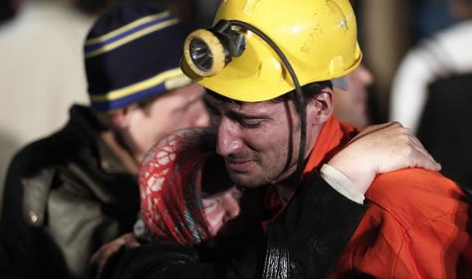A.

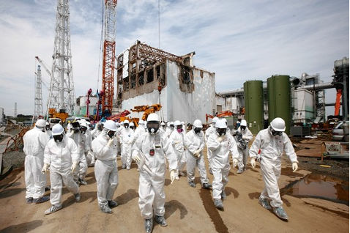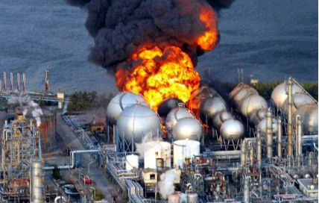

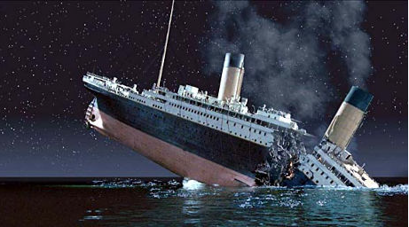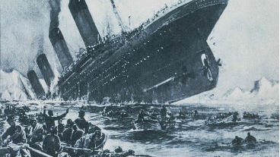

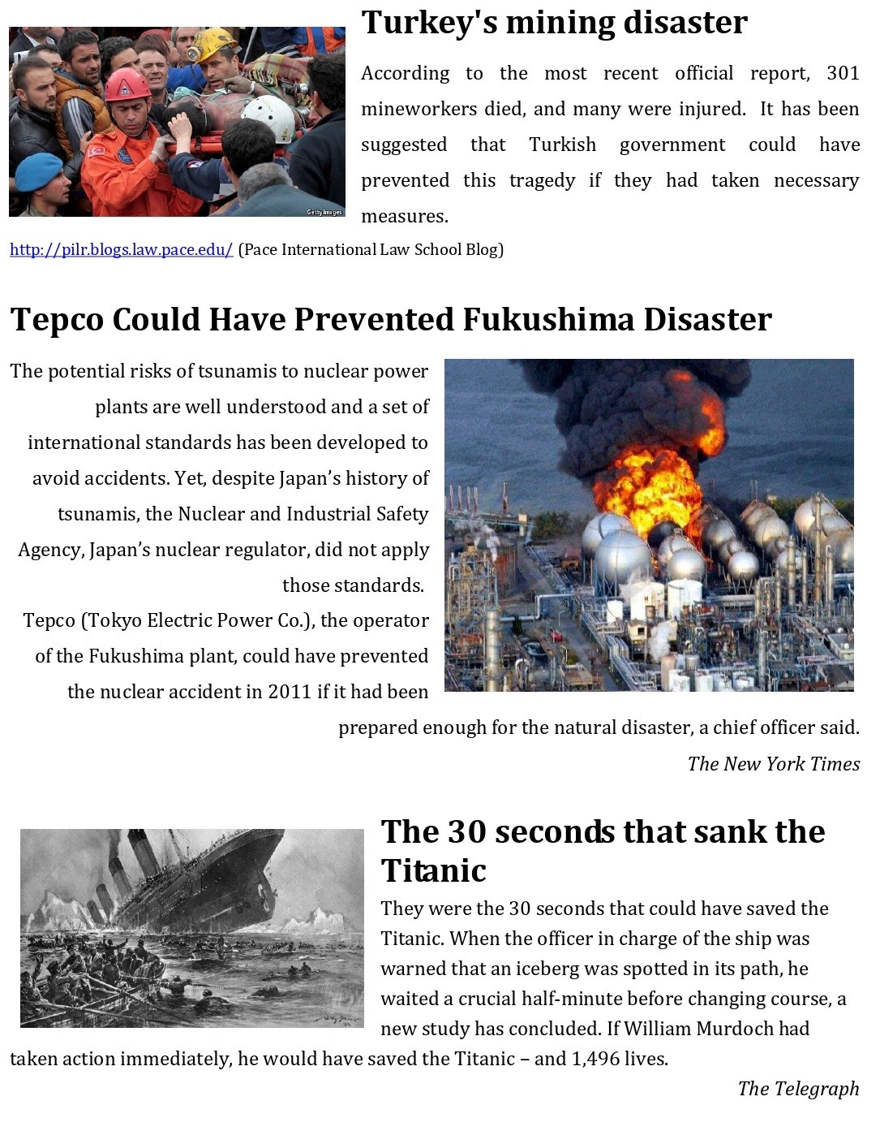B.

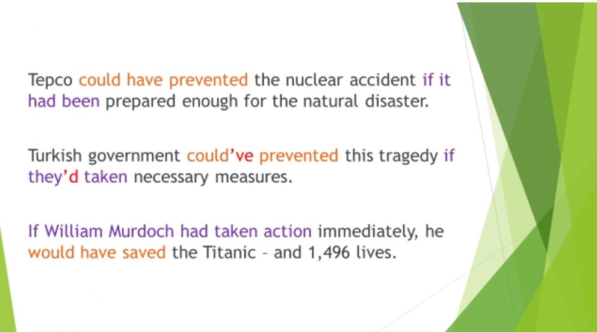C.

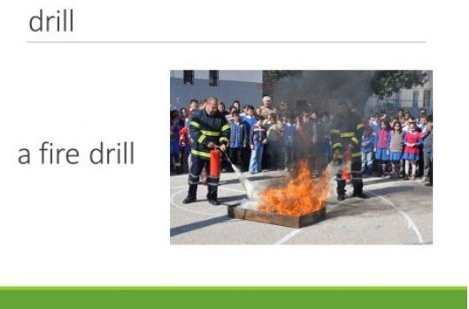

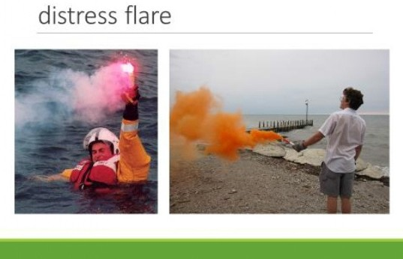

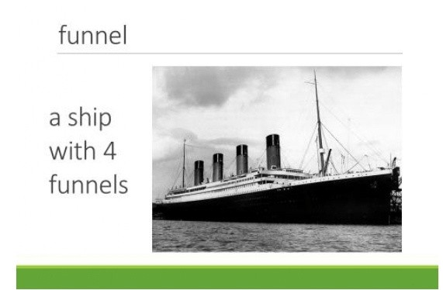

D.

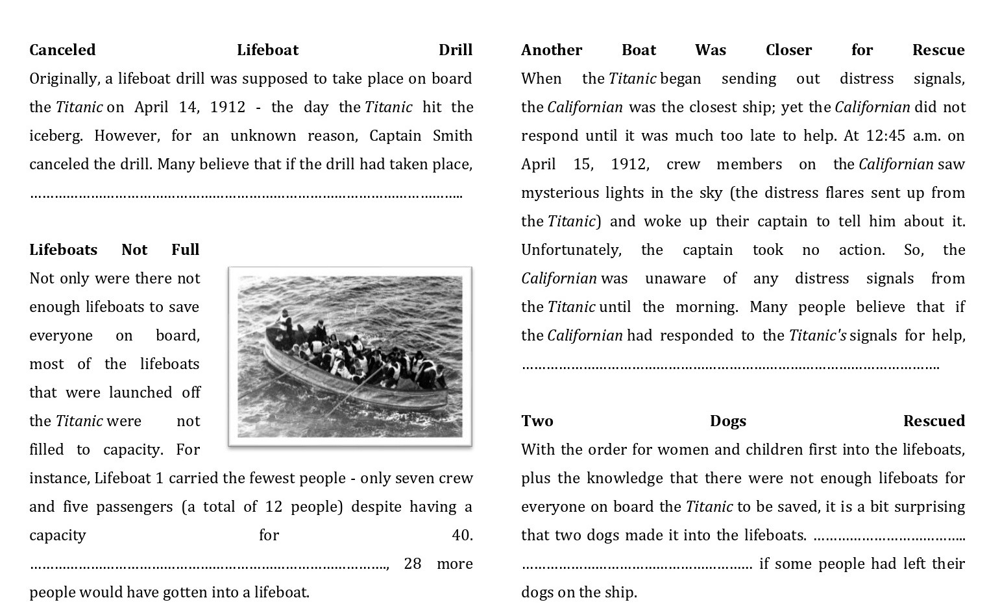

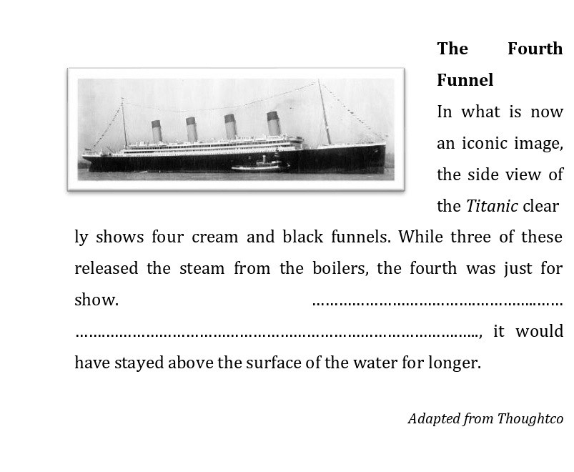

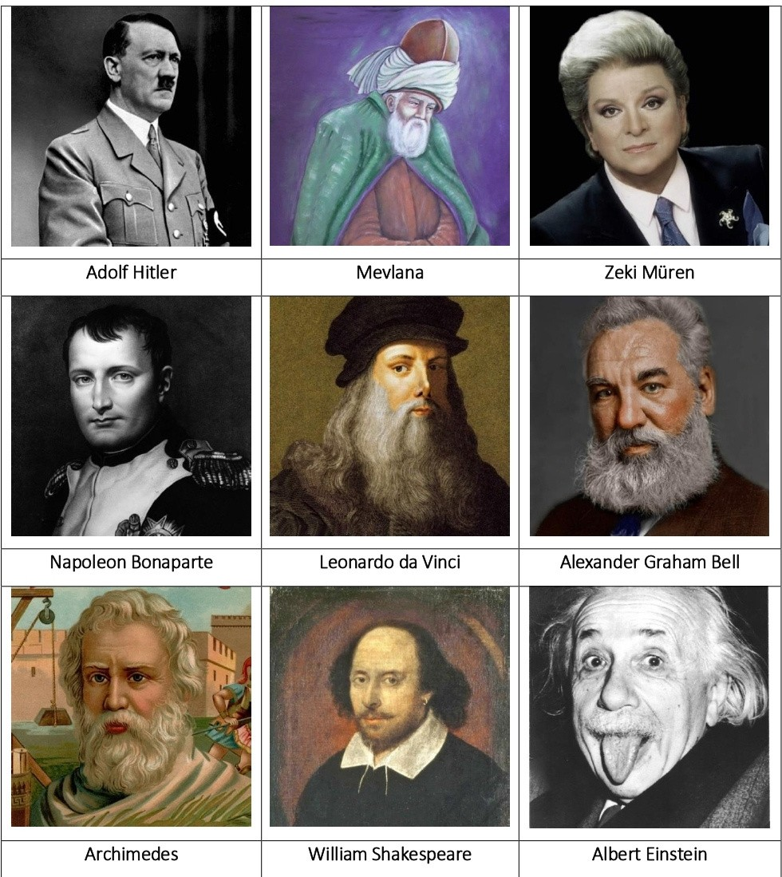E.

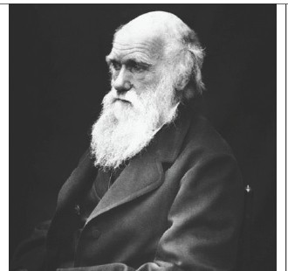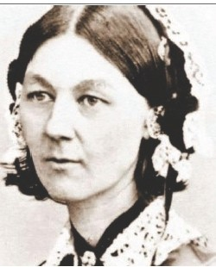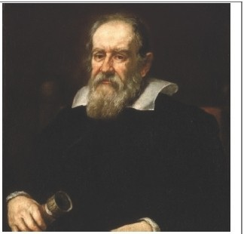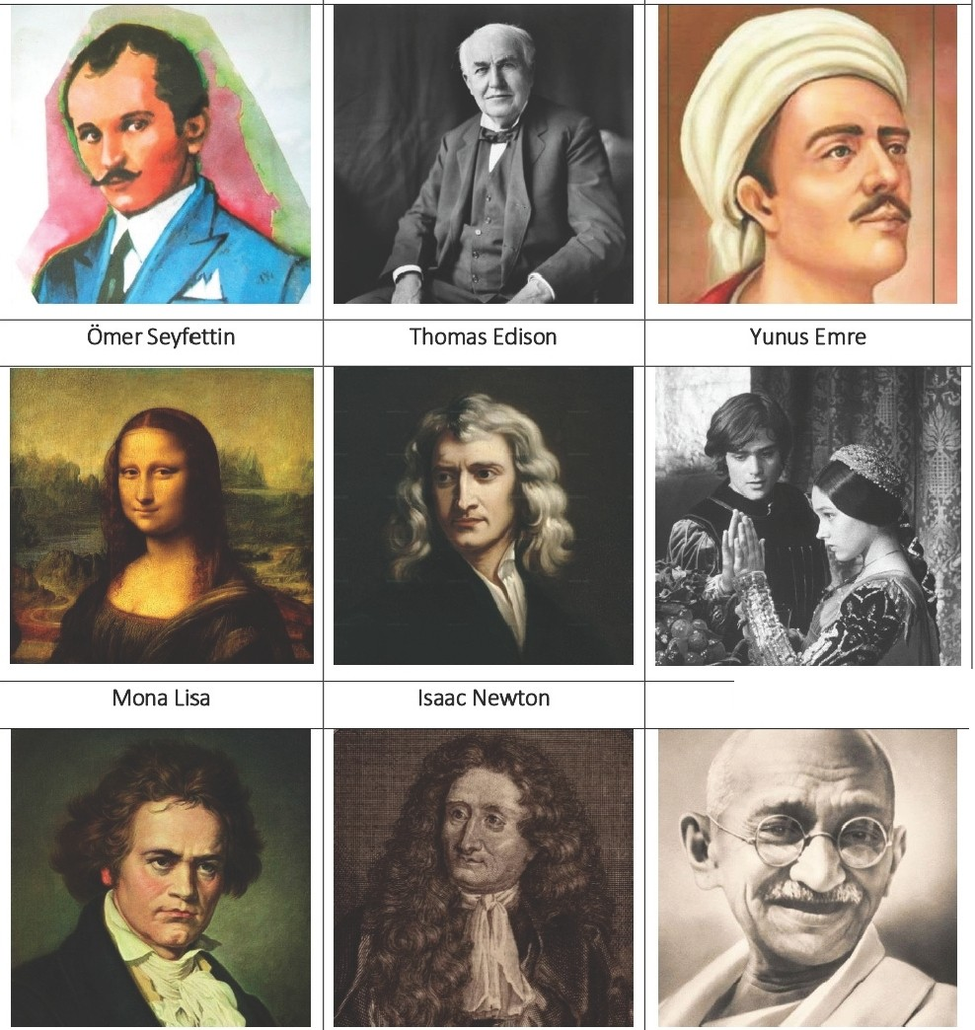
Charles Darwin
Florence Nightingale
Galileo
Romeo & Juliet

Beethoven
La Fonta ine
Mahatma Gandhi

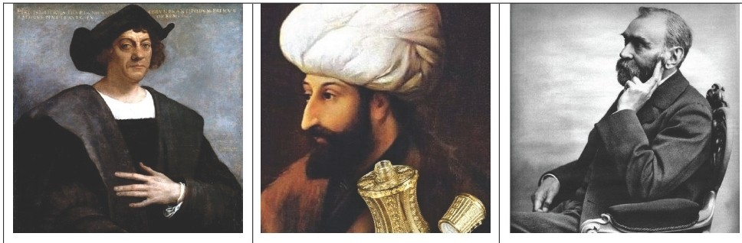
Christopher Columbus
Fatih Sultan Mehmet
Alfred Nobel

F.

