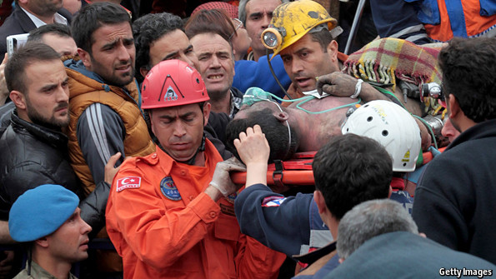
Turkey's mining disaster
According to the most recent official report, 301 mineworkers died, and many were injured. It has been suggested that the Turkish government could have prevented this tragedy if it had taken the necessary measures.

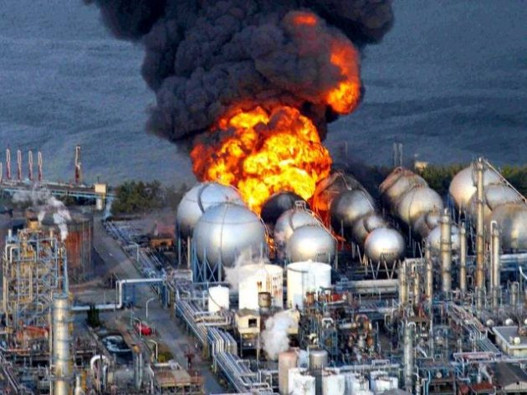
TEPCO could Have Prevented the Fukushima Disaster
The potential risks of tsunamis to nuclear power plants are well understood, and a set of international standards has been developed to avoid accidents. Yet, despite Japan’s history of tsunamis, the Nuclear and Industrial Safety Agency, Japan’s nuclear regulator, did not apply those standards.
TEPCO (Tokyo Electric Power Co.), the operator of the Fukushima plant, could have prevented the nuclear accident in 2011 if it had been prepared enough for the natural disaster, a chief officer said.

The 30 seconds that sank the Titanic
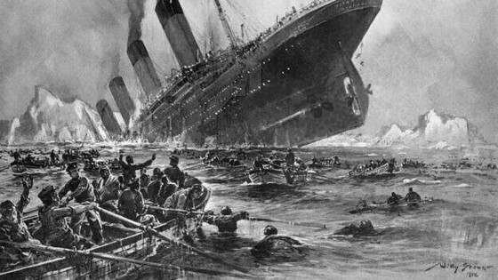
They were the 30 seconds that could have saved the Titanic. When the officer in charge of the ship was warned that an iceberg was spotted in its path, he waited a crucial half-minute before changing course, a new study has concluded. If William Murdoch had taken action immediately, he would have saved the Titanic and 1,496 lives.

