5 Facts about the Titanic That You Don't Know

Canceled Lifeboat Drill
Originally, a lifeboat drill was supposed to take place on board the Titanic on April 14, 1912 - the day the Titanic hit the iceberg. However, for an unknown reason, Captain Smith canceled the drill. Many believe that if the drill had taken place, ……………………………… …………………………………………………………………………………………………...
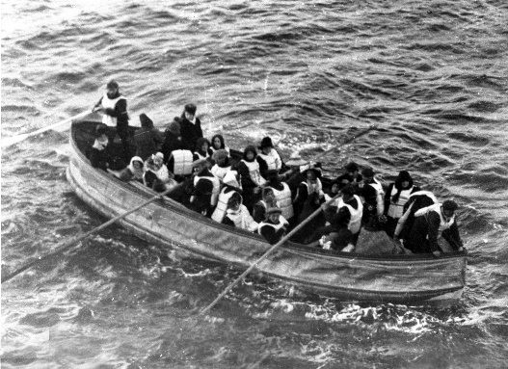
Lifeboats Not Full
Not only were there not enough lifeboats to save everyone on board, but most of the lifeboats that were launched off the Titanic were not filled to capacity. For instance, Lifeboat 1 carried the fewest people - only seven crew and five passengers (a total of 12 people) despite having a capacity for 40. ……………………………………………………………………………., 28 more people would have gotten into a lifeboat.

Another Boat Was Closer for Rescue
When the Titanic began sending out distress signals, the Californian was the closest ship; yet the Californian did not respond until it was much too late to help. At 12:45 a.m. on April 15, 1912, crew members on the Californian saw mysterious lights in the sky (the distress flares sent up from the Titanic) and woke up their captain to tell him about it. Unfortunately, the captain took no action. So, the Californian was unaware of any distress signals from the Titanic until the morning. Many people believe that if the Californian had responded to the Titanic's signals for help, …………………………………………………… …………………………………………………………………………………………………

Two Dogs Rescued
With the order for women and children first into the lifeboats, plus the knowledge that there were not enough lifeboats for everyone on board the Titanic to be saved, it is a bit surprising that two dogs made it into the lifeboats. ………………………………………………………………………… if some people had left their dogs on the ship.

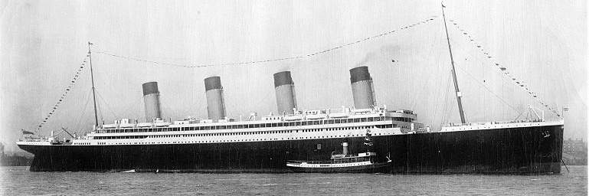
The Fourth Funnel
In what is now an iconic image, the side view of the Titanic clearly shows four cream and black funnels. While three of these released the steam from the boilers, the fourth was just for show. ………………………………………………. …………………………………………………………………….….., it would have stayed above the surface of the water for longer.

