LESSON PLAN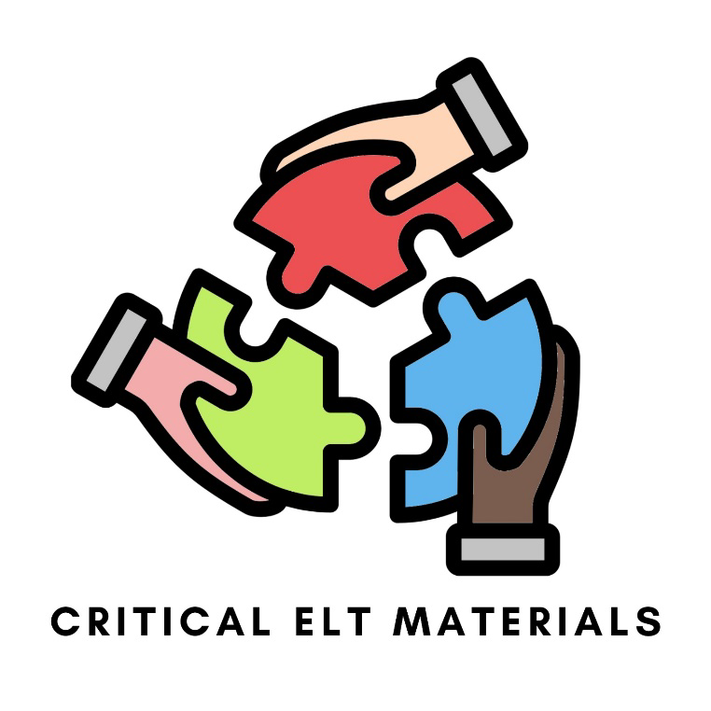
by Esma Çelikbilek, Ada Gökduman, Özge Sıla Akkoca

Suggested Grade Level: 3rd grade (9 years old, elementary level)
Materials Needed: [Ministry of National Education 3rd Grade Coursebook] Koçak, Esengül Primary School English Grade 3, Unit 10: “Nature” Dikey Yayıncılık, 2023, pp. 155-166. ,
visual prompts, info-gap worksheets, blank papers, crayons, sample campaign poster design, whiteboard, board markers, smartboard.
Length of Time: 40 + 40 minutes

Goals:
By the end of the lesson:
- Students will identify the target vocabulary items related to nature and animals.
- Students will develop an awareness of the environmental issues concerning animal habitats.
- Students will propose solutions for habitat protection through communicative tasks.

Objectives:
• By the end of the presentation stage, students will identify the 11 target vocabulary items (bee, bear, dolphin, forest, frog, ladybird, mountain, pigeon, sea, shark, whale) related to nature and animals using visual prompts.
• By the end of the practice stage, students will exchange information about animal locations through an information-gap activity.
• By the end of the production stage, students will design a campaign poster for a chosen animal.
• By the end of the production stage, students will formulate one creative rule to protect their chosen animal's habitat.

Process:

1. Lead-in & Presentation (25'): Greet the students and ask them how they are. Then, display a series of contrasting visual prompts (Appendix A) on the board, showing animals in pristine natural habitats versus polluted environments. Show the images one by one: a pigeon in nature vs. a dirty street, a frog on a lily pad vs. sitting on plastic waste, a whale and a dolphin in clear blue oceans vs. swimming through plastic bottles and rings, a bee on a flower vs. flying near factory smoke, and a bear in a natural cave vs. rummaging through suburban trash cans.
Ask students to share how the two different situations make them feel to activate prior knowledge and empathy, introducing the problem that human actions are harming these animals’ homes. As the class discusses who needs help finding a clean home, explicitly introduce the target nature and animal vocabulary. Write the words (bee, bear, dolphin, forest, frog, ladybird, mountain, pigeon, sea, shark, whale) on the board and have the students repeat the words out loud to practice pronunciation and connect the form to the meaning.

2. Practice (30'): Distribute the information gap worksheets (see Appendix B). Students pair up for the two-way "Contrast Animal Rescue" information gap task. Both learners get an "Emergency Map," which consists of six different zones (clean sea, green forest, beautiful flower, beach filled with plastic waste, dirty street, smoggy factory). However, their maps are incomplete.
Student A's map includes three animals in three different zones (2 in clean places and 1 displaced in a polluted place), while empty spots are provided for three other animals. Student B's map includes three animals in three polluted places and one in a clean place. Besides their maps, they get short explanations of why the displaced animals are in those particular places (e.g., "The bear's forest is polluted. The bear is in the city street!").
In that case, neither of the learners will be able to guess since they lack certain information. Furthermore, the displaced animals do not have their logical place; thus, both of them should ask and answer real questions in order to understand and create the map (for example, Student A asks, “Does the shark live in the clean sea?”, and Student B answers, “No, it doesn’t because there is some plastic in the sea, and the shark lives on the beach.”).
3. Production (25'): Students form small groups, and each group chooses one rescued animal from the vocabulary they care about the most. They must design a “Save the [Animal]” campaign poster. Show the sample poster (Appendix C) to the whole class. They brainstorm what might be hurting the animal (e.g., plastic bottles hurting the shark) and write one creative rule or solution for their community. At the end of the lesson, students present their posters to the class. Finally, hang the posters on the classroom board or hallway walls so the students can view them anytime.
Contingency Plan: The teacher whispers a target vocabulary word (e.g., mountain, dolphin) to a volunteer. The student silently draws the word on the whiteboard while the rest of the class guesses the correct English word.

Assessment and Evaluation:
No homework is specified.

Appendices:

Appendix A:
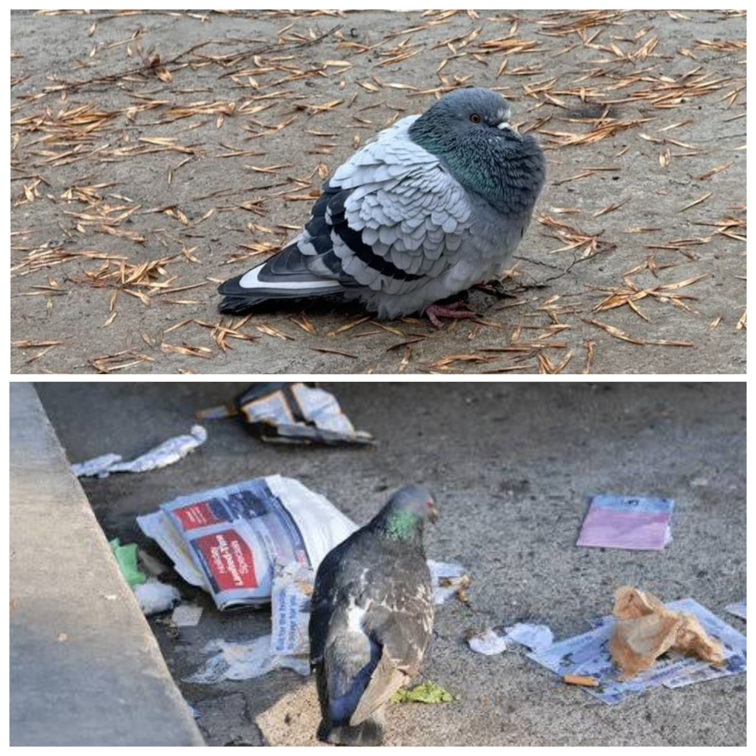
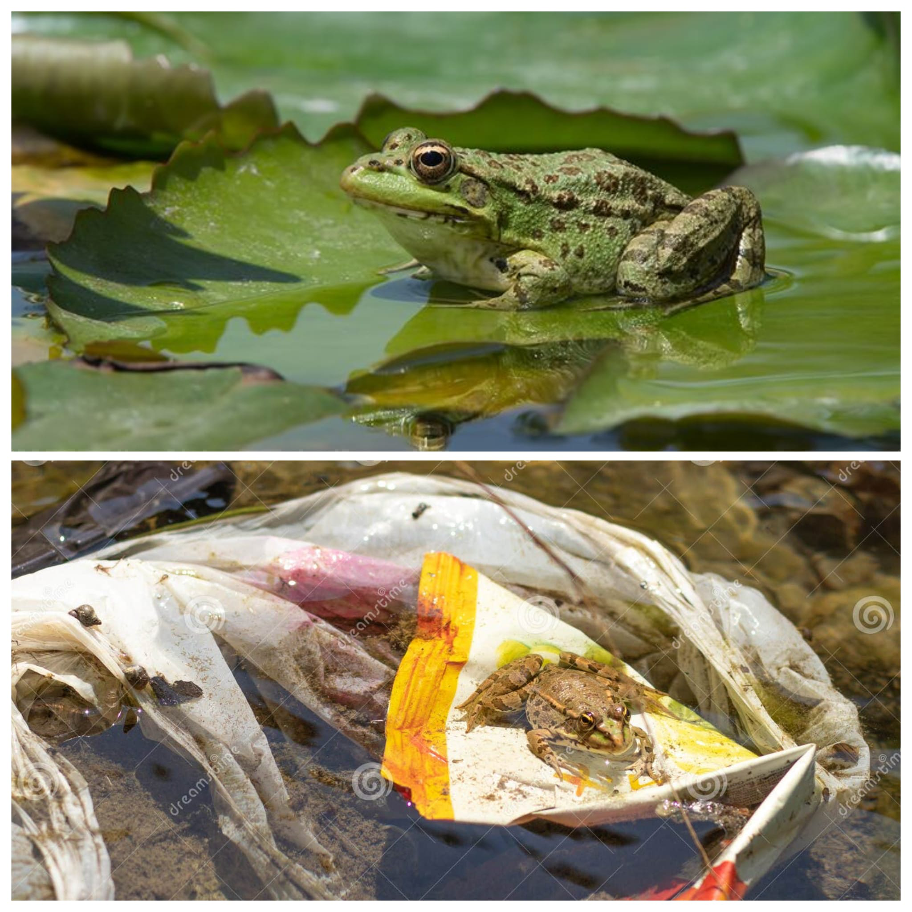
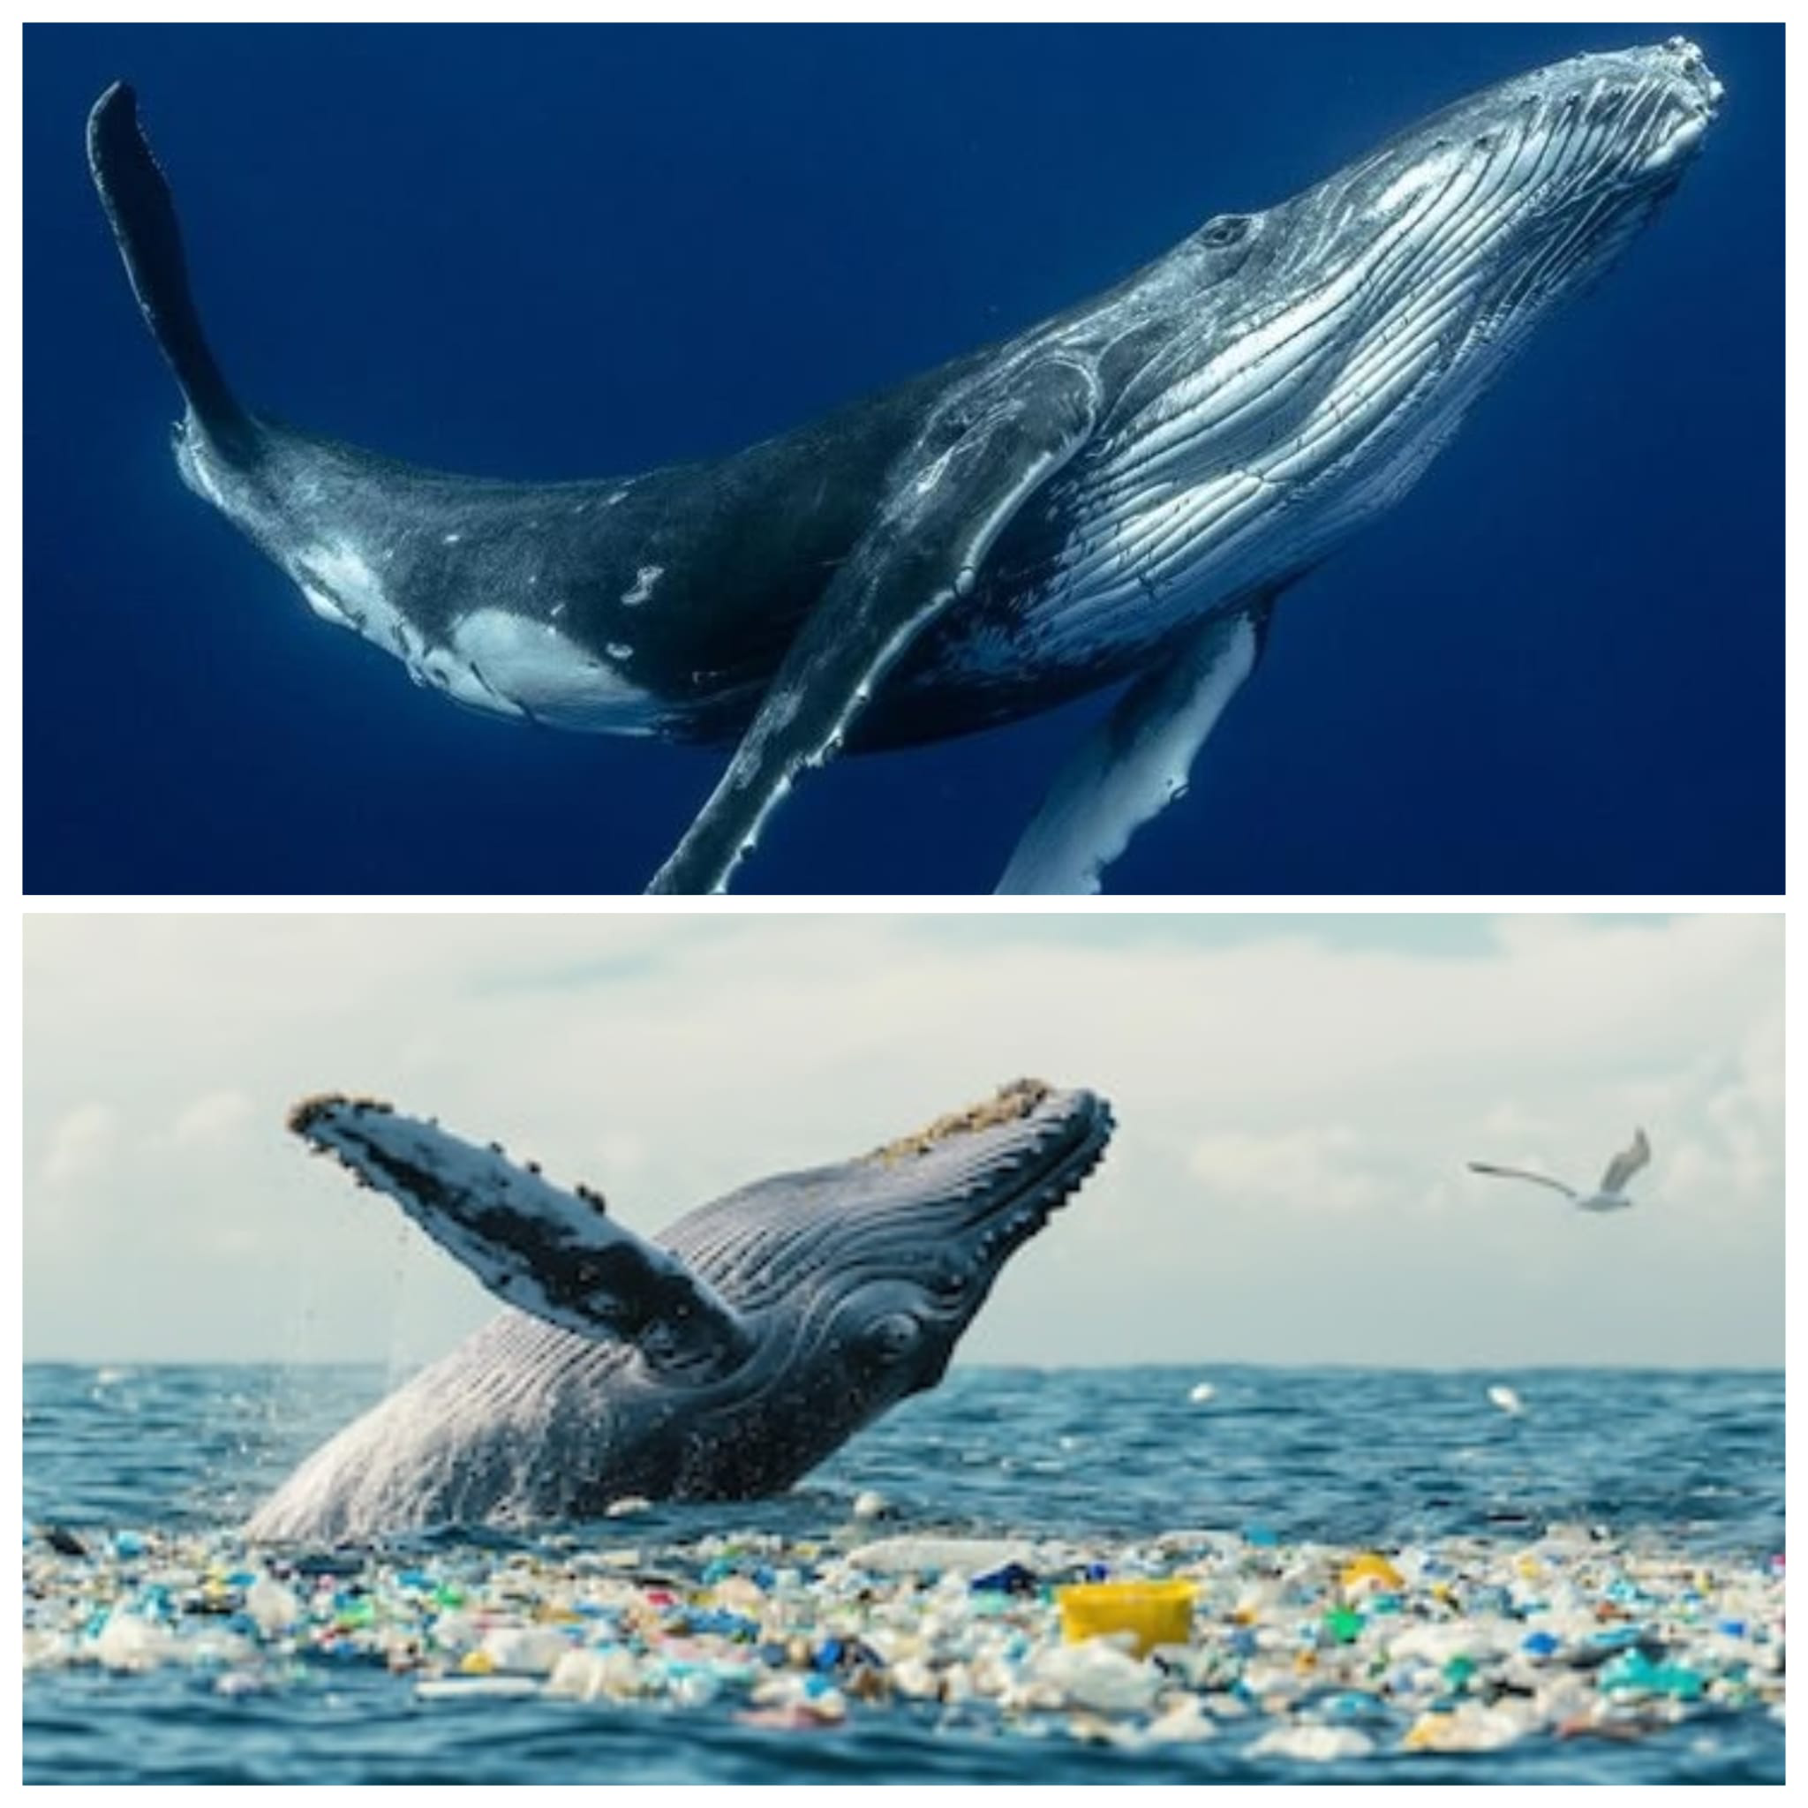
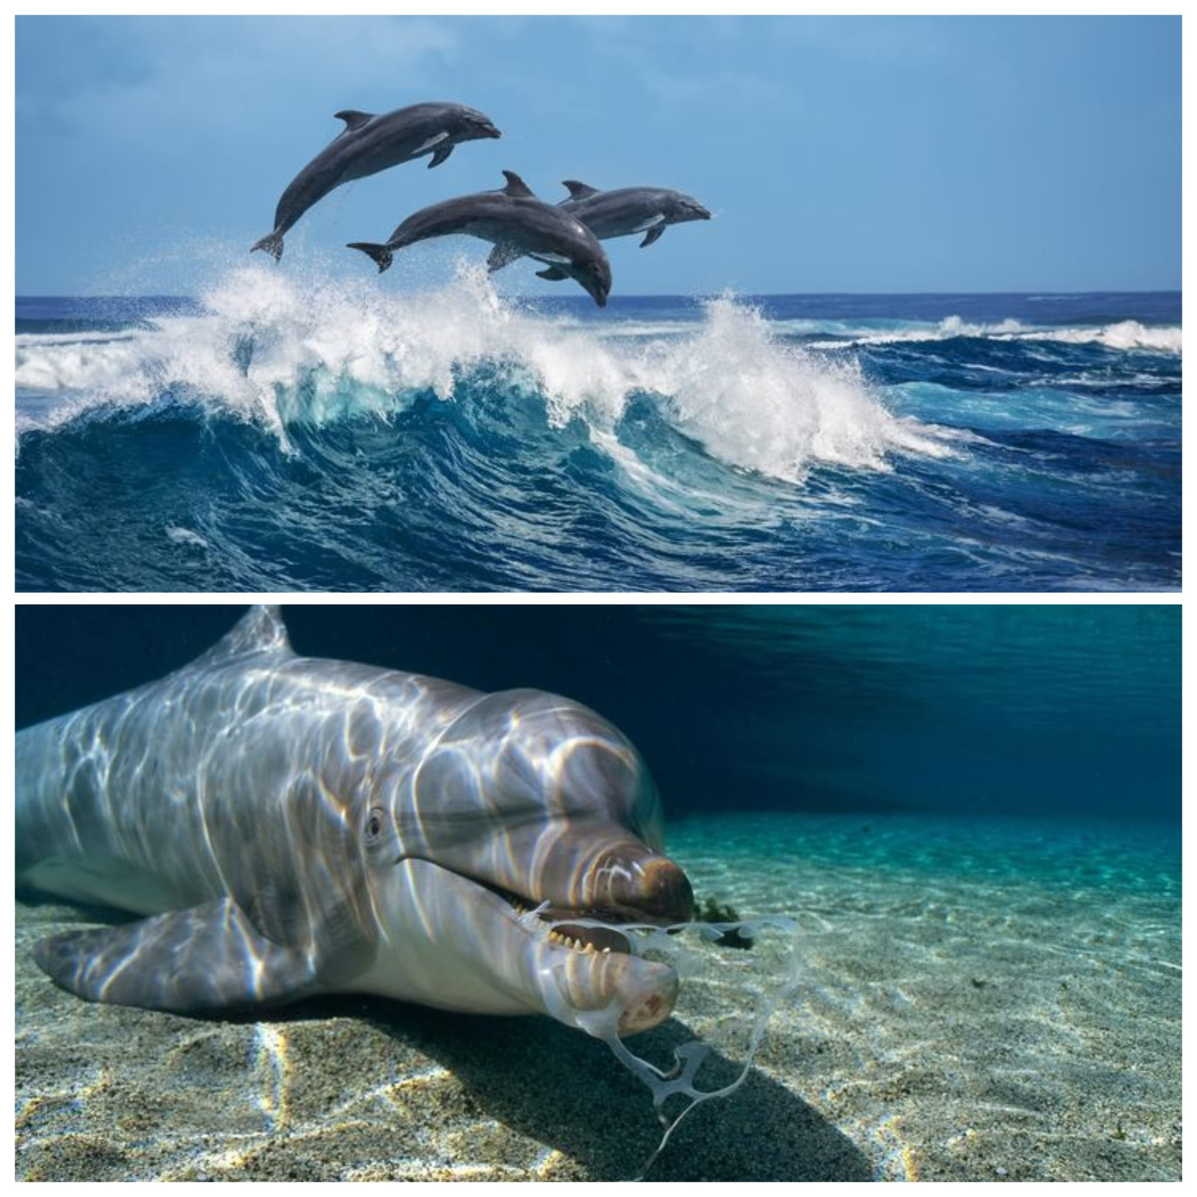
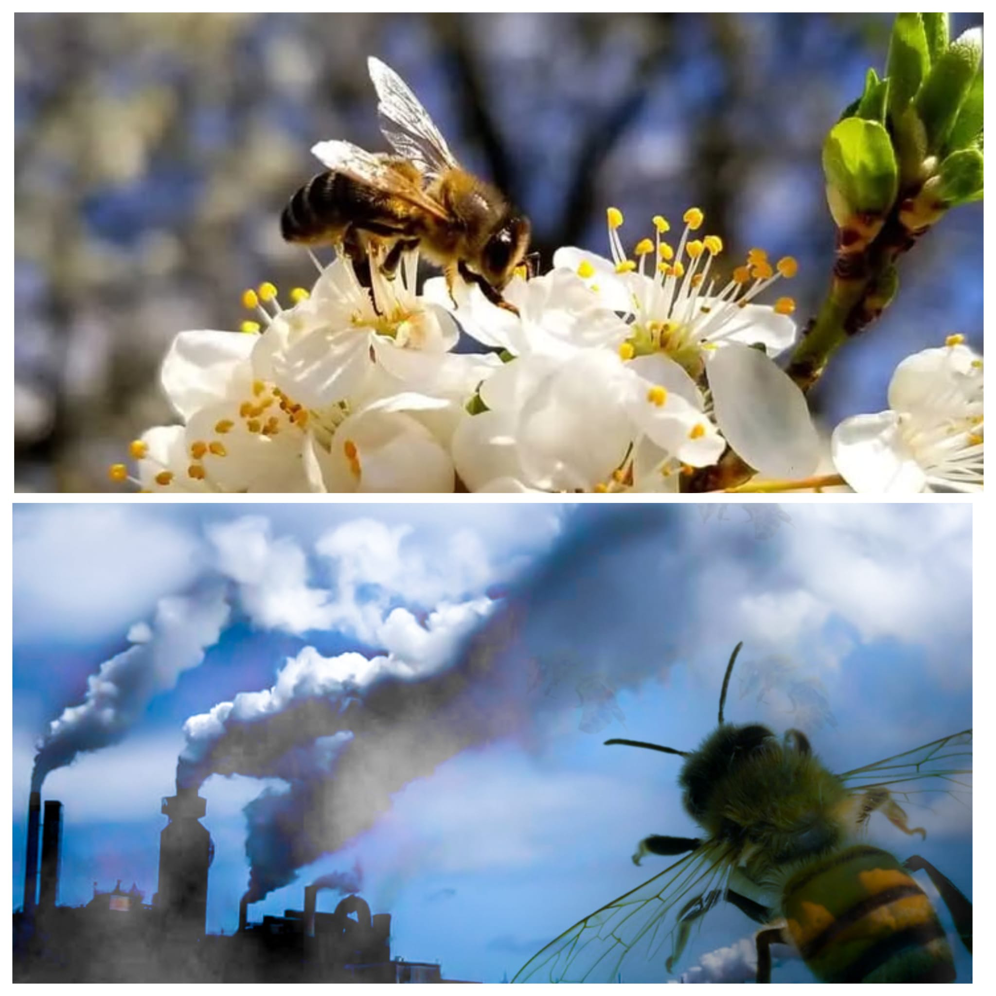
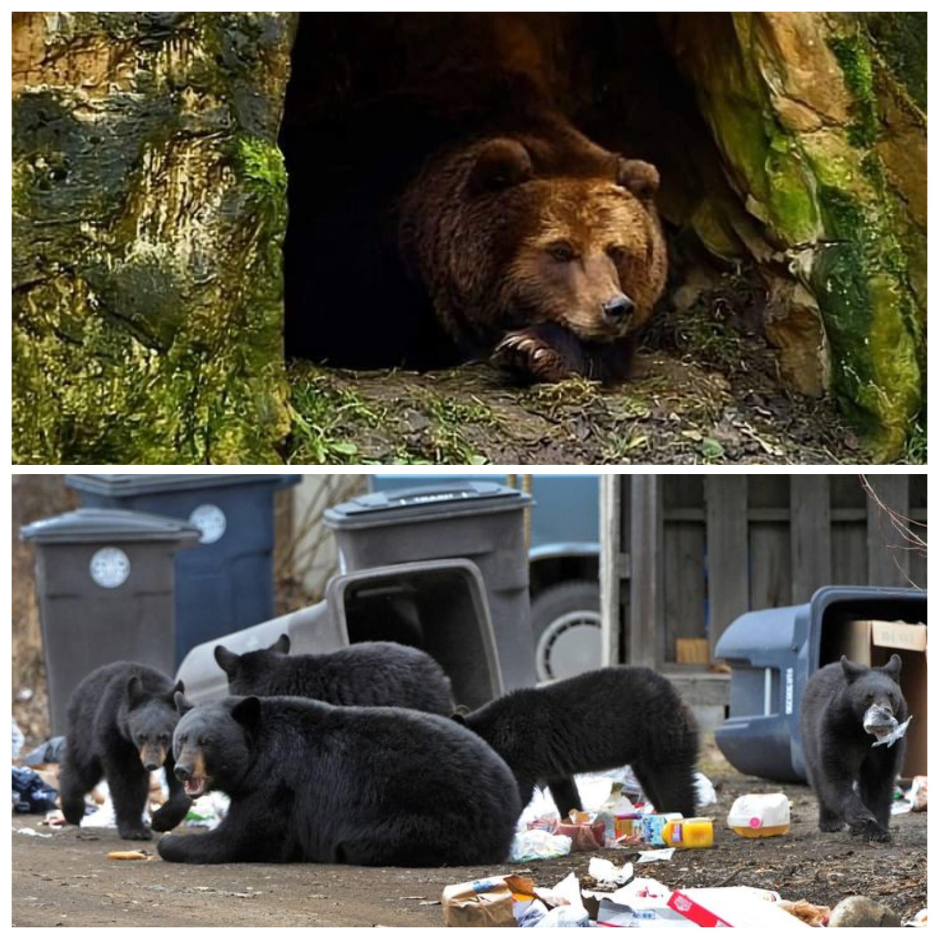

Appendix B:

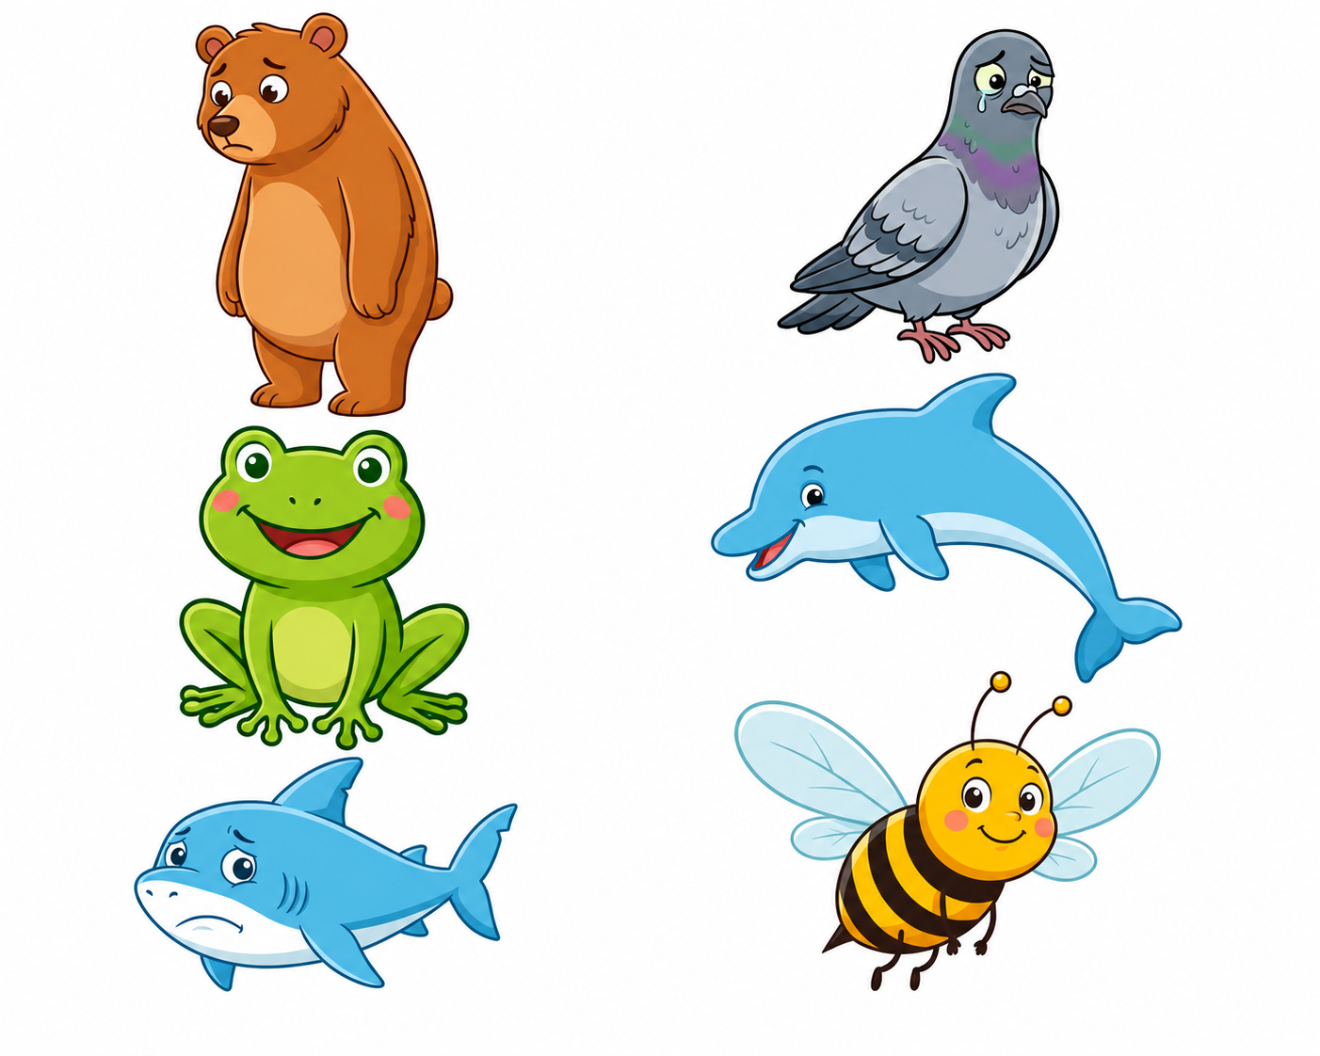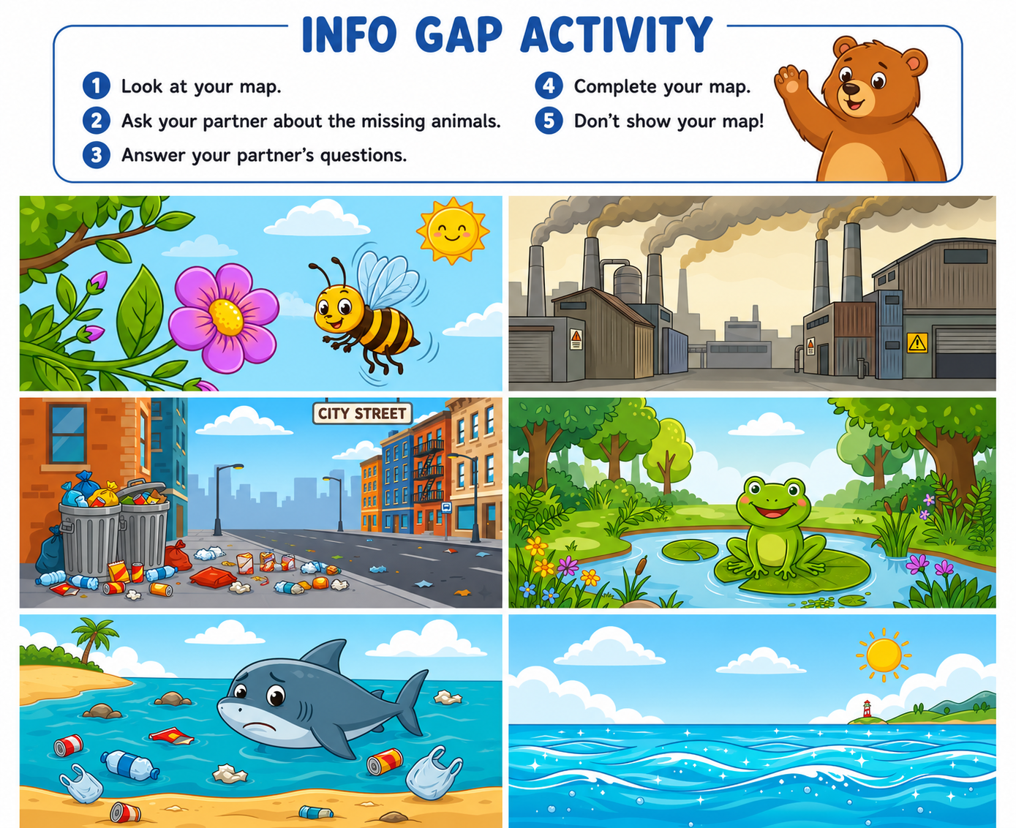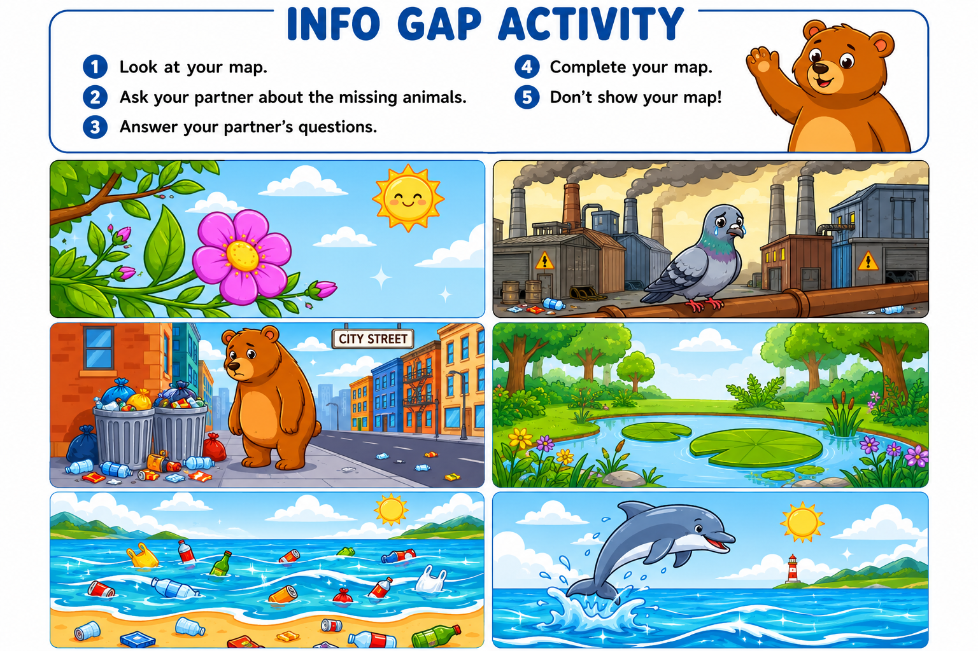

Appendix C:
